Republic of The Gambia

National Emergency Telecommunications Plan

(NETP)

DRAFT Ver 4.0 for Comment
November 2024

Republic of The Gambia

National Emergency Telecommunications Plan

This draft is incomplete and based on publicly available information. There may be inaccuracies and inconsistencies in this information. Consequently, this draft should be used for discussion and clarification purposes only at this stage. As new or corrected information is provided, the draft will be updated accordingly. This may lead to changes in the implementation actions.

This NETP is subject to review by the Government of the Republic of The Gambia. Comments will be included in the final version.
This report was prepared by the International Telecommunication Union (ITU) expert Brad Partridge.
Sydney, Australia, November 2024.

Contents
Introduction 7
Objective and Scope of the NETP 7
Structure of the NETP 8
Summary of the Implementation Actions for The Gambia 9
1. Description of the Four Phases of Disaster Management 26
1.1 Mitigation 26
1.2 Preparedness 27
1.3 Response 27
1.4 Recovery 28
2. Early Warning for All Initiative (EW4ALL) 29
3. Legislation, Policies and Plans Related to Disaster Risk Management 33
3.1 National Disaster Management Policy 2007 33
3.2 The National Disaster Management Act, 2008 35
3.2.1 Disaster Declaration or State of Public Emergency 35
3.2.2 National Disaster Fund 36
3.3 Customs and Excise Act 36
3.4 National Climate Change Policy 36
4. Plans, Policies and Programs Related to Disaster Management 38
4.1 Recovery Focused National Development Plan 2023-2027 38
4.2 The Gambia 2050 Climate Vision 39
4.3 National Broadband Policy 2020-2024 39
5. Agencies Involved in Disaster Risk Management 41
5.1 National Disaster Management Council 41
5.2 National Disaster Management Agency 42
5.3 Public Utilities Regulatory Authority 42
5.4 Ministry of Communications and Digital Economy 43
5.5 Gambia ICT Agency 43
5.6 The Gambia Meteorological Division 44
5.7 National Sectors 44
5.8 National Emergency Telecommunication Cluster 44
5.9 World Food Program (WFP) – Emergency Telecommunications Cluster (ETC) 45
6. Specific Telecom/ICT Regulatory Provisions 47
Mitigation Phase 50
7. Vulnerability to Disasters from Natural Hazards in The Gambia 50
7.1 Overview 50
7.1.1 Flood 51
7.1.2 Drought 51
7.2 Vulnerability Maps 51
7.3 Critical Infrastructure Vulnerability Analysis 53
8. Telecom/ICT sector in The Gambia 55
8.1 Overview 55
8.2 Domestic Networks Overview 56
8.2.1 Backhaul Networks 56
8.2.2 Access Networks 58
8.3 Mobile Networks 59
8.4 International Connectivity - Submarine Cables 62
8.4.1 Cable Breaks 64
8.5 International Connectivity - Satellites 64
8.5.1 Low Earth Orbit (LEO) Satellite Providers 65
8.5.2 VSAT 66
8.5.3 Broadband Global Area Network (BGAN) 66
8.5.4 Satellite Phones 67
8.6 Spectrum Management 67
8.6.1 Frequencies for Public Protection and Disaster Relief (PPDR) Region 1 67
8.6.2 Models for Use of Frequencies for PPDR 68
8.6.3 Trunked Radio 69
8.7 Broadcast Services 69
8.8 Other Networks and Telecommunications Equipment 69
8.8.1 Humanitarian Networks 70
8.8.2 Radio Amateurs 70
9. International Cooperation 72
9.1 Tampere Convention 72
9.2 Africa Risk Capacity Agreement 73
9.3 Crisis Connectivity Charter (CCC) 74
9.4 International Charter on Space and Major Disasters 74
9.5 United Nations Disaster Assessment and Coordination (UNDAC) 74
9.6 United Nations (UN) Agencies 75
Preparedness Phase 77
10. Early Warning and Alert Systems 77
10.1 Early Warning System Architecture 77
10.1.1 Monitoring Systems 78
10.1.2 Message Creation 80
10.1.3 Alert Dissemination 82
11. Training and Drills 88
12. Support for People with Specific Needs 90
13. Contingency Plans 92
14. Standard Operating Procedures (SOP) 93
Response Phase 95
15. Emergency Operations Centre - Communication and Coordination 95
16. Collection and Analysis of Information 97
17. Contact Centre for Emergency Awareness and Updates 98
Recovery Phase 99
18. Assessment of Damage, Reconstruction, and Improvement of Infrastructure 99
19. Recovery Activities Follow-up 100
Annexes 101
A1. Inventory of Telecom/ICT networks 101
A2. Disaster Management Network 103
A3. Private Networks 103
A4. Contact Information 103
A5. International Support 103
A6. Standard Operating Procedures 103
A7. Contingency Plans 104
B1. A Simplified Guide to Using the NETP 105
Acronyms 107
References 110

List of Tables
Table 1 - Implementation Matrix 18
Table 2 – The Gambia Sector Structure 44
Table 3 – Natural Disaster in The Gambia 1920 - 2024 50
Table 4 - Hazard Effects on Telecommunications Infrastructure 53
Table 5 – The Gambia Telecom Statistics 55
Table 6 - Frequency Bands Adopted for PPDR 68
Table 7 – Emergency Frequency Allocation 68
Table 8 - Humanitarian Networks 70
Table 9 - Summary of CB/LB-SMS characteristics 85

List of Figures
Figure 1 - Phases of Disaster Risk Management 26
Figure 2 - Pillars of the EW4ALL Initiative 30
Figure 3 - The Gambia Disaster Management Framework 34
Figure 4 – The Gambia River Flood Hazard Map 52
Figure 5 – The Gambia Drought Hazard Map 52
Figure 6 – ECOWAN Infrastructure Map 57
Figure 7 – The Gambia Terrestrial and Subsea Fibre Infrastructure Map 58
Figure 8 – The Gambia Microwave Infrastructure Map 58
Figure 9 – Gamcel Combined GSM and 3G Network Coverage 59
Figure 10 – Africell Combined GSM, 3G and LTE Network Coverage 59
Figure 11 – QCell Combined GSM, 3G and LTE Network 60
Figure 12 - Crowdsourced Coverage - Comium 60
Figure 13 - Crowdsourced Coverage Data - Gamcel 61
Figure 14 - Crowdsourced Coverage - Africell 61
Figure 15 - Crowdsourced Coverage - QCell 62
Figure 16 – Africa Coast to Europe Route 63
Figure 17 - African Satellites by Country 65
Figure 18 - EWS Top Level Architecture 78
Figure 19 – African Flood and Drought Monitor 79
Figure 20 - Common Alerting Protocol (CAP) 81
Figure 21 - Example CAP Message 81

Introduction
The National Emergency Telecommunication Plan (NETP) is a strategic plan that enables communications and exchange of information about natural hazards, disaster risks, and how to use telecommunications/ICTs to respond to disaster events at all government levels, within communities, and between public and private organizations.
The NETP describes the policies, organizational structure, and methods of coordination between the different actors during all four phases of disaster management. It provides a snapshot of available telecom/ICT resources and responsibilities for achieving disaster risk mitigation, as well as responding to emergency events.
The impact of, and reliance on, telecom/ICTs in all phases of disaster risk management (DRM) is increasingly crosscutting in nature. Therefore, the NETP must be carried out under the leadership of the national government, be an integral part of the National Disaster Management Plan and be built under the organizational structure and governance model established for disaster risk management nationwide.
Objective and Scope of the NETP
The primary objective of The Gambia NETP is to:
- Describe the legal and policy frameworks and organizational structures and mechanisms that currently exist for each of the four phases of disaster management in The Gambia in general and consider more specifically the aspects of each that apply to emergency telecommunications.
- Understand the potential natural hazards that The Gambia faces and how the telecommunications infrastructure might be impacted by these hazards, so that contingency plans for communication can be put in place
- Explore how telecommunications/ICT can be used to monitor the hazards and prevent loss of life and livelihoods through early warning systems
- Guide the actions of the telecom/ICT sector to provide support and improve coordination between the different agents involved in disaster risk management in the country.
- Pursue the strengthening of telecom/ICT infrastructure in The Gambia to support efforts to mitigate disaster risk, and prepare for, respond to and recover from natural disasters.
The NETP is intended for all persons and institutions involved in Disaster Risk Management (DRM) in The Gambia, including authorities at all levels of government, the private sector, and other actors in the telecom/ICT and emergency aid sectors.
Structure of the NETP
This document is divided into 18 chapters. Chapters 1-6 describe the existing institutional framework for emergency telecom/ICTs in The Gambia. Chapters 7-18 refer to the main components that are considered for each of the four phases of DRM and delineate recommendations that need to be carried out to continue developing and updating the NETP. Chapters 7 through 9 correspond to the mitigation phase of DRM and deal with such topics as the country’s vulnerability to natural hazards, the current state of the telecom/ICT sector, and the establishment of a specific telecom/ICT regulatory framework for DRM. Chapters 10 through 14 correspond to the preparedness phase of DRM and include topics related to telecom/ICT standard operating procedures, contingency planning, and early warning systems. The response phase of DRM is covered in Chapters 15 through 16, which discuss topics like communication and coordination during any emergency response, collection and analysis of information, and emergency awareness and updates. Finally, the recovery phase for DRM is addressed in Chapters 17 and 18, which present topics such as the assessment of damage to the telecom/ICT infrastructure, and the reconstruction and follow- up activities will need to be carried out after the disaster.

Summary of the Implementation Actions for The Gambia
To be updated following stakeholder consultation
The following Action Items are identified for consideration for implementation:
Item 1: Laws and Regulations for DRM and National Disaster Management Plans
In case these are not currently in place, high-level laws and regulations for DRM should be established. This comprehensive legal, policy, and institutional framework should be based on the existing DRM policy and include national disaster management plans and be specific in defining the agencies accountable for developing emergency sectorial regulations.
Implementation
It is clear that, at least at this legislative and policy levels, DRR has been actively considered and attempts have been made to provide for the mainstreaming of DRR at all levels in various sectors. For the most part, the legislation, policies and plans are outdated and require review and enhancement to address any shortcomings when considered against best practice examples.
The opportunities for enhancement should consider
- The role of Information Technology and Communications within the DRM framework and particularly with respect to defining and leading these sectors during a disaster situation.
- Stronger policy and regulation on the implementation of early warning systems.
- Stronger policy surrounding agencies implementing monitoring systems to ensure that the NDMA is notified of such systems.
- Clarity with respect to duty exemptions for disaster relief goods and materials
- Stronger community involvement.
- Consideration of the role of woman and those disadvantaged.
As an implementation task the NDMA should consider a holistic review of the DRM framework, legislation and policies and compare against best practice examples.
Item 2: National Disaster Plan and National Emergency Telecommunications Plan
Each Countries National Disaster Plan and National Emergency Telecommunications Plan should be developed or updated based on the legislation for DRM currently in force in each country.
Implementation
Implementation Task 2
The key implementation task from this section is the development and completion of the Namibian NETP. However, there are several other plans that are now seen as out of date and should be reviewed and brought into a best practice position.
Item 3: Responsibilities and activities for the Ministry responsible for Telecom/ICT and the Telecoms NRA
Based on the general national DRM laws and regulations, the Government should define the clear responsibilities and activities for the Ministry responsible for telecom/ICT and the Telecoms NRA in each Member State. These should include the specific roles that the Ministry and the Telecoms NRA must play within the general DRM system, and the roles and representation they have within the sectoral committees or sub-committees for DRM in each Member State.

Implementation
Many provisions are in place for DRM, either in existing plans or in associated legislation and policy. However, in many cases the plans are out of date and consequently do not align with what would be considered best practice. Similarly, provisions in legislation should be clarified to clearly show those provisions that align with DRM activities.
- A National Emergency Telecommunications group/cluster should be established that provides input into the NETP on an ongoing basis and take part in the implementation tasks identified in the NETP
- A Terms of Reference (ToR) for this cluster including appropriate information on members should be developed as an addendum to this NETP
- The National Disaster Management Policy should be reviewed and updated, particularly regarding the Sectors and the functions associated with the sectors. A clear communications sector should be implemented into this plan to show the importance and relationship of telecommunications to DRM
- Provisions identified should be clearly identified in the appropriate legislation and regulations as to their relationship to DRM.
Item 4: Provisions for Emergency Telecom/ICTs
Based on the mandate of a high-level DRM law or policy, the responsible agency for developing regulations for emergency telecom/ICTs should make provisions for different topics related to emergency telecom/ICTs for all phases of DRM (mitigation, preparedness, responses, and recovery).
Implementation
The Public Utilities Regulatory Authority (PURA) is responsible for establishing specific regulations for the telecom/ICT sector on disaster risk management. These regulations should be based on its functions granted by legislation, encouraging telecom/ICT network and service providers to actively participate in each of the phases of disaster risk management. Consequently, PURA should review and enhance the regulatory framework that facilitates the use of telecommunications resources in each of the phases of disaster management for the local telecom/ICT services sector.
PURA should undertake a review of specific regulations that have a DRM aspect and consider updating these regulations to reflect best practice and explicit application to DRM. Areas that could be addressed include (but are not limited to) those presented in the following sections.
- Mitigation and Preparedness Phases
- Oblige telecommunications service providers to carry out vulnerability analyses of their networks according to risk maps of different geographical areas and to establish corresponding contingency plans that guarantee, to the extent possible, vital communications for emergency management and disaster risk reduction, as well as the timely restoration of user communications. These plans should be submitted to and approved by PURA.
- Ensuring that the associated legal instruments have explicit wording to ensure that temporary arrangements for spectrum licenses, operational licenses, type approvals or other such matters can be expedited in a disaster situation without Ministerial consent.
- Require that radio and commercial broadcasting operators, public and private television broadcasting operators, as well as civil society entities with assigned radio frequencies, transmit information campaigns for the mitigation of disasters and emergencies. These campaigns should be developed in coordination with NDMA and the PURA and should have a regulated duration and broadcasting timeline.
- Require that radio and commercial broadcasting operators, public and private television broadcasting operators, as well as mobile providers, disseminate CAP alerts to inform the population of a hazard accurately and in a timely manner.
- Response Phase
- Ensure that providers of commercial fixed and mobile telecommunications services take the necessary measures to make available their networks and sufficient capacity for communications to the authorities and affected population, free of charge and in a timely manner, as soon as a disaster situation or emergency is declared.
- Require providers of commercial mobile service to encourage their customers to send SMS messages instead of other means of communication such as voice or data services, to avoid network congestion. Also, require that commercial telecommunications, fixed and mobile service providers, to limit the duration of calls to, for example, a maximum of 2 minutes in the geographic area of the disaster for a period of 12 hours following the event that generates the emergency. These norms would not apply to calls made from or to the numbers of the authorities involved in the emergency response.
- Ensure that providers of commercial fixed and mobile telecommunications services give priority in communications to calls made by the authorities for a period of 24 hours after the emergency is declared, extendable as decided by the responsible authority (e.g. DMD).
- Oblige radio broadcasting, commercial and community operators, as well as public and private television broadcasting operators, to transmit messages from DMD to inform and update the public about the disaster. These messages could include helpful content regarding health services, shelter, food, and family reunification, among others.
- Oblige telecommunications service providers to immediately assess the damage to their networks and implement the previously prepared contingency plans, to re-establish communications as soon as possible. The different government entities, through the PURA, should support and facilitate the implementation of those contingency plans.
- Recovery Phase
- Require commercial and telecommunications service providers to re-establish permanent solutions to restore and improve communications to end users, with the aim of building back better, in alignment with the Sendai Framework.
Item 5: Updated Vulnerability Maps
Each Member State should maintain updated vulnerability maps for the different types of hazards in the NETP and especially those related to droughts, floods, and epidemics.
Implementation
Maintaining and ensuring hazard maps for the different types of hazards that exist is an essential contributor to disaster planning and the development of mitigation strategies.
- The NDMA should lead, develop and approve updated vulnerability maps for the different types of hazards, and especially those related to droughts, floods, and epidemics developed and maintained by the relevant agencies involved in assessing and monitoring natural hazards in The Gambia.
- This information must be described at the municipal level and be available to telecom/ICT operators. It should also include information on the most vulnerable communities, specifying the type of hazards they are prone to, as well as the telecom/ICT resources available for each of them.
- PURA should ensure that all telecom/ICT service operators, mobile, fixed, and radio and television broadcasting operators, as well as government networks, in conjunction with PURA, should develop (or update) and present for approval a vulnerability analysis of the critical infrastructure of their networks, including an inventory of the infrastructure, and power, maintenance and connectivity evaluations along with consideration of the risks associated with cybersecurity (to obtain the cooperation of private, commercial entities, (it may be necessary to put in place confidentiality or non-disclosure agreements).
- This activity could be carried out with the support of the academic institutions and relevant planning departments and go beyond any current practise of collating information to become more proactive curation of data, identifying gaps and driving project requirements to expand and maintain GIS/Hazard Map information.
Item 6: Critical Infrastructure and Network Inventory
All telecom/ICT service operators, mobile, fixed, and radio and television broadcasting operators, as well as Government networks, in conjunction with the NRA should develop (or update) and present for approval to the DRM Authority a vulnerability analysis of the critical infrastructure of their networks according to the different types of hazards to which the country is prone to.
Implementation
An up-to-date repository of critical infrastructure is important in a disaster situation. Whilst this information does not have to be held by PURA, there must be confirmation that the information is available, regularly updated and can be accessed when required. Therefore, PURA should put in place a methodology to regularly review the network inventory and coverage of mobile and fixed telecom/ICT operators, and radio and television broadcasting.
All telecom/ICT service operators, mobile, fixed, and radio and television broadcasting operators, as well as government networks, in conjunction with the PURA, should develop (or update) and present for approval to the NDMA a vulnerability analysis of the critical infrastructure of their networks, including an inventory of the infrastructure, and power, maintenance and connectivity evaluations along with consideration of the risks associated with cyber security.
PURA should also, maintain an updated database with the focal points in charge of technical aspects as well as with those in charge of communication of alerts and relevant information regarding disasters. Include network information and coverage of radio amateurs and first responders (police, firefighters, etc.) and identify any gaps.
PURA should also consider the assessment of the implementation of other options on telecom/ICT infrastructure, such as including satellite devices for voice/broadband communications, academic networks and community WiFi to strengthen emergency response and recovery activities
Information should be confirmed on VSAT capability in the country, including those systems already in situ and systems in storage for use as required.
Coverage maps of all mobile network operators should be reviewed and updated accordingly. Coverage maps should be easily available to the public for information purposes and should be available at a detailed level on an as-required basis.
Item 7: The Tampere Convention and Coordination with International Agencies
Countries that are not signatory to the Tampere Convention should initiate the process to become part of it.
Implementation
As a non-signatory to the Tampere Convention, the relevant government agencies or entities in The Gambia, including the customs authority, should review existing regulations to simplify or create exemptions to any regulation that prevents the use of telecom/ICT resources for international aid to allow for The Gambia to become a signatory and ensure effective implementation of the Convention
Continue to maintain contacts in and work in co-operation with different international agencies, such as the International Telecommunications Union (ITU), the ETC (Emergency Telecommunications Cluster), other international bodies and with regional partners on issues related to preparedness and response to disasters or emergencies.
Item 8: Early Warning Systems and Common Alerting Protocol
Each Country should assess, develop and/or enhance existing emergency alert and EWS, including surveillance and monitoring systems for probable threats prior to the occurrence of disasters and/or emergencies and solutions for warning and alerting the public through using different means of communications.
Implementation
Implementation Task 8:
NDMA, MoCDE and PURA should conduct an audit of monitoring solutions and systems that are currently in place in The Gambia. This will provide the necessary input information for an aggregator solution for the early warning system.
The Gambia must continue to develop surveillance and monitoring systems for probable threats prior to the occurrence of disasters and/or emergencies however these should be integrated into any early warning system that is to be developed.
Utilising this information NDMA and MoCDE should move to develop and improve the early warning and alerting systems strategy including the implementation/development of a centralised alert aggregator to take advantage of the Common Alert Protocol (CAP) and to help with consistent, authoritative, impact-based forecast and alert messaging. The appropriate staff should undertake WMO’s online CAP training, a CREWS workshop if not already undertaken or an ITU CAP Implementation Workshop.
The current Common Alerting Protocol (CAP) Alerting implementation should be examined to assess its efficacy and identify opportunities for expanding its reach to as broad several different channels as possible. Any dependencies for downloading applications to mobile devices should be assessed for limitations in scope and coverage.
PURA should work with the carriers to develop/implement a Cell Broadcast capability to send alerts via the mobile network infrastructure. Ideally this will build on the CAP implementation.
PURA should work with broadcasters to develop/implement the capability to send alerts via the broadcast radio and TV network infrastructure. Ideally this will build on the CAP implementation
The role of amateur radio should also be reviewed to establish opportunities for further refinement.
Item 9: Training and Drills
Telecommunications trainings and drills for emergencies should be regularly carried out to improve emergency responders’ capacity with communications equipment as well as to enhance their ability to execute policies, plans, and procedures governing the use of communications networks.
Implementation
Training and drills should occur in all the areas identified throughout the planning process, including institutional capacity and management of telecom/ICT networks. Telecom/ICT training and drills for emergencies should be regularly carried out to improve emergency responders’ capacity with telecom/ICT equipment, as well as to enhance their ability to execute policies, plans and procedures governing the use of telecommunications networks.
Table-top exercises (TTX), or discussions of a simulated emergency in a low-stress environment, should conducted, to test the NETP and other procedures for improvement.
The telecom/ICT sector, as well as any other relevant actors involved in telecom/ICT management including enablers for ICT (such as power and transport agencies for example), should actively participate in these drills and exercises, and develop and carry out their own, to effectively implement the NETP. These sector-specific exercises and drills should be coordinated with those developed by other relevant stakeholders to avoid duplication of efforts. The ICT simulation exercise can be conducted at national (strategic level) and sub-national (tactical level).
Item 10: Accessibility
Each country’s DRM Authorities – including the Ministry responsible for telecom/ICTs and the Telecoms NRA, working together with network operators and telecom/ICT service providers, should develop mechanisms to understand the accessibility requirements needed to guarantee that vital digital communication technologies are inclusive and, therefore, are accessible to all persons, including People With Disabilities (PWDs), the elderly, women and girls, and refugees and immigrants.
Implementation
The Gambia’s authorities, working together with network operators and telecom/ICT service providers, should develop mechanisms to guarantee that vital telecommunication technologies are inclusive and therefore accessible to all persons, including people with disabilities, the elderly, women and girls, as well as refugees and immigrants. This should be linked to the early warning systems.

Where possible, working in collaboration with network providers, these messages should be via geo-location capabilities to those at risk.

All warning messages should be issued in the most appropriate languages and sign language and/or captions and infographics should be used where appropriate for the medium.

Item 11: Contingency and Business Continuity Plans
Public and private satellite and terrestrial networks, including mobile, fixed, and broadcasting operators must each keep their contingency and business continuity plans for emergencies updated.
Implementation
Telecom/ICT network and service providers must develop contingency plans for emergencies in line with any updated national plans, and in conjunction with the authorities responsible for telecom/ICTs and for disaster risk management. Measures such as network redundancy, secondary energy sources, and developing solutions for international cable cuts, among others, must be considered and included in the network design, especially in those areas at risk according to the hazard maps, and considering the network vulnerability analysis.
Item 12: Standard Operating Procedures
Develop, update and strengthen SOPs for emergency and disaster response related to communications within and among agencies and technical means for communication (voice/data), including interoperability.
Implementation
PURA/MoCDE/NDMA in conjunction with the participants in the Telecommunications Emergency Cluster should:
- Continue to develop and update the NETP Standard Operating Procedures for emergency and disaster response related to communications within and between agencies and network operators including the technical means for communication (voice/data), and interoperability. This should include an exhaustive list of all actions that may be required for disaster response.
- Define the government entities and the contact points (key decision makers) within these entities that must maintain communication during a disaster or emergency.
- Maintain an updated database with these focal points of every agency, and where appropriate any associated partner organisations, countries, or other external entities, involved in disaster management.
- Analyse the possible interoperability between the equipment (wireless) and the communication networks of the government entities.
- Establish a set of radio frequencies that can be used for the communications of the contact points (key decision makers) compatible with the radiocommunication equipment being used and ensure it is aligned for regional compatibility.
- Establish alternative methods of communications, if necessary, for example through existing communication operators.
- Develop connectivity plans for the satellite equipment available, if that is the case, to be used during a response phase as well as procedures for their use as primary or alternative communications between relevant stakeholders involved in disaster response

Item 13: Emergency Operations Centres
Consider planning for the development of Emergency Operations Centres (EOCs) or communication and coordination command posts to provide critical communications to users in each organisation involved during the response phase of a disaster.
Implementation
Consider planning for the support of the Emergency Operations Centres or communication and coordination command posts to ensure that critical communications to stakeholders, first responders and the community is reliable.
Consider the telecommunication aspects of positions that may be fixed in a different location, mobile, local, or remote, and in a vehicle or in a shelter, among other possibilities. Maintaining interoperable and continuous communications between command posts and the rest of the stakeholders, Shelters and other key locations, is vital for an effective response to the emergency. The network connectivity to Shelters needs to be checked to ensure it is reliable, stable, and able to cope with expected demands.
Develop Standard Operating Procedures (SOPs) for all emergency operations centres (EOCs) that include the coordination and communication procedures and roles for every stakeholder involved in the process, such as public and private persons and agencies, and international humanitarian actors, among others. These emergency operations centres should also have defined locations and determined equipment and telecom/ICT infrastructure requirements.

Item 14: Call Centres
Plan for the establishment of call centres during the response phase. These should be established to warn the affected population of new risks, disseminate updates about the emergency situation, and connect affected populations with their relatives.
Implementation
Investigate how call centres, potentially located in the EOC or shelters, can be established during the response phase to warn the affected population of new risks, to disseminate updates about the emergency, and to connect affected populations with their relatives, using means of communication that do not congest the networks (cell broadcast, CAP, infographics, text messages, geo-located information dissemination).
To establish these call centres, The Gambia could seek collaboration with telecom/ICT operators or international organisations to establish the required building and telecom/ICT infrastructure.
Item 15: Restoration and Reconstruction of the Telecom/ICT Infrastructure
Restoration and reconstruction of the telecom/ICT infrastructure should be based on lessons learned and the principle of building back better. These activities should also involve the active participation of the private sector, including fixed, mobile, and satellite network and service providers.
Implementation
Restoration and reconstruction of the telecom/ICT infrastructure should be based on lessons learned and on the principle of building back better. These activities should involve the active participation of the private sector service providers.
Assessment, reconstruction, and improvement of telecom/ICT infrastructure can be supported on the Post Disaster Needs Assessment framework.
Item 16: NETP Update
Based on the experience acquired during the disaster management, a report should be developed after the response and recovery phases that identifies lessons learned and includes necessary modifications and improvements that should be made to the NETP. The NETP should be updated every 2 to 3 years.
Implementation
After the response and recovery phases and based on the experience acquired during the disaster management or during any drills and exercises conducted, a report should be developed identifying lessons learned and including the necessary modifications and improvements that should be made to the NETP. The NETP should be reviewed every year before cyclone season and updated where necessary.
PURA should review and provide feedback to the ITU on any progress, changes or NETP action items that have been implemented by an agreed timeframe (for example, six or nine months) after the validation of the NETP.
A simplified and tabulated version of the implementation tasks is provided in Table 1 below
Table 1 - Implementation Matrix
Implementation Task | Activity | Lead | Timeframe to Commence
1 | Consider a holistic review of the DRM framework, legislation and policies and compare against best practice examples within the African community. | NDMA | Now - Ongoing
2 | Completion and implementation of The Gambian NETP | PURA | Now - Ongoing
3 | Establish a National Emergency Telecommunications group that provides input into the NETP on an ongoing basis and takes part in the implementation tasks identified in the NETP | PURA | Now
3 | Develop a Terms of Reference (ToR) for this cluster including appropriate information on members should be developed as an addendum to this NETP | PURA | 6 Months  Update Annually
3 | Review and update The National Disaster Management Policy cluster information particularly regarding the Sectors and the functions associated with the sector | NDMA | 6 Months
3 | Create a communications Sector/Cluster to highlight the importance and relationship of telecommunications/ICT to DRM | CHECK AND CONFIRM
4 | Review, develop and establish specific regulations for the telecom/ICT sector on disaster risk management. These regulations should be based on its functions granted by legislation, encouraging telecom/ICT network and service providers to actively participate in each of the phases of disaster risk management | PURA | 6 Months
5 | Develop and enhance vulnerability maps for the different types of hazards, especially those related to droughts, floods, and epidemics developed and maintained by the relevant agencies involved in assessing and monitoring natural hazards in The Gambia. | NDMA/Academia | 6 - 12 Months  Update Annually
5 | All telecom/ICT service operators, mobile, fixed, and radio and television broadcasting operators, as well as government networks, should develop (or update) and present for approval a vulnerability analysis of the critical infrastructure of their networks. | PURA | 12 Months  Update Annually
6 | Create a repository or knowledge base of critical infrastructure to be used in a disaster situation. | PURA | Now – Ongoing  Update Annually
6 | Establish a methodology to regularly review the network inventory and coverage of mobile and fixed telecom/ICT operators, and radio and television broadcasting. | PURA | 12 Months
6 | Maintain an updated database with the focal points in charge of technical aspects as well as with those in charge of communication of alerts and relevant information regarding disasters. Include network information and coverage of radio amateurs and first responders (police, firefighters, etc.) and identify any gaps. | PURA | 6 Months  Update Annually
6 | Assess other options such as LEO satellite services, academic networks and community WiFi to strengthen emergency response and recovery activities | PURA | 12 Months
6 | Compile information on  VSAT capability in the country, including those systems already in situ and systems in storage for use as required. | PURA | 12 Months  Update Annually
6 | Coverage maps of all mobile network operators should be reviewed and updated accordingly. Coverage maps should be easily available to the public for information purposes and should be available at a detailed level on an as-required basis. | PURA | Now  Update Annually
6 | PURA should work with industry and subsea cable operators to consider the options for a second cable landing to ensure redundancy and resilience of this infrastructure. | PURA | 6 Months
7 | As a non-signatory to the Tampere Convention, the relevant government agencies or entities in The Gambia should review existing regulations to simplify or create exemptions to any regulation that prevents the use of telecom/ICT resources for international aid | OPM/MoFA/MoCDE | Review process  6 – 12 Months
7 | Based on the outcome above, The Gambia should move to become a signatory and ensure effective implementation of the Convention | OPM/MoFA/MoCDE | 12 - 24 Months
7 | Continue to maintain contacts in and work in co-operation with different international agencies, such as the International Telecommunications Union (ITU), the ETC (Emergency Telecommunications Cluster), other international bodies and with regional partners on issues related to preparedness and response to disasters or emergencies. | MoCDE/PURA | Ongoing
8 | Conduct an audit of monitoring solutions and systems that are currently in place. This will provide the necessary input information for an aggregator solution for the early warning system. | NDMA/MoCDE | 6 Months
8 | Continue to develop surveillance and monitoring systems for probable threats prior to the occurrence of disasters and/or emergencies | NDMA/MoCDE | Ongoing
8 | The current Common Alerting Protocol (CAP) Alerting implementation should be examined to assess its efficacy and identify opportunities for expanding its reach to as broad several different channels as possible. Any dependencies for downloading applications to mobile devices should be assessed for limitations in scope and coverage. | NDMA/MoCDE/PURA | 12 Months
8 | Move to develop and improve early warning and alerting systems strategy including the implementation/development of a centralised alert aggregator and Common Alert Protocol (CAP) to help with consistent, authoritative, impact-based forecast and alert messaging. | NDMA/MoCDE | 12 Months
8 | Work with the MNO’s to develop/implement a Cell Broadcast capability to send alerts via the mobile network infrastructure. Ideally this will build on the CAP implementation. | PURA | 12 Months
8 | Work with broadcasters to develop/implement the capability to send alerts via the broadcast radio and TV network infrastructure. Ideally this will build on the CAP implementation | PURA | 12 Months
8 | Review the role of amateur radio and actively encourage and build capacity of the amateur radio enthusiasts for disaster recovery situations. | PURA | 6 Months  Ongoing
9 | Training and drills should occur in all the areas identified throughout the planning process, including institutional capacity and management of telecom/ICT networks. Telecom/ICT training and drills for emergencies should be regularly carried out to improve emergency responders’ capacity with telecom/ICT equipment, as well as to enhance their ability to execute policies, plans and procedures governing the use of telecommunications networks. | MoCDE/NDMA/PURA | Ongoing regular schedule
9 | Table-top exercises (TTX), or discussions of a simulated emergency in a low-stress environment, should conducted, to test the NETP and other procedures for improvement. | MoCDE/NDMA | Annually
10 | Working together with network operators and telecom/ICT service providers, develop mechanisms to guarantee that vital telecommunication technologies are inclusive, accessible and linked to the early warning systems. | NDMA/PURA | 18 Months
10 | Where possible, working in collaboration with network providers, these messages should be via geo-location capabilities to those at risk. | NDMA/PURA | 12 Months
10 | All warning messages should be issued in the most appropriate languages and sign language and/or captions and infographics should be used where appropriate for the medium. | NDMA | 12 Months
11 | Telecom/ICT network and service providers must develop contingency plans for emergencies in line with an updated National Emergency Management Plan, and in conjunction with the authorities responsible for telecom/ICTs and for disaster risk management. | PURA | Now  Review annually
12 | Develop or update Standard Operating Procedures for emergency and disaster response related to communications within and between agencies and network operators including the technical means for communication (voice/data), and interoperability. This should include an exhaustive list of all actions that may be required for disaster response | NDMA/PURA | Now  Initial review to establish which SOPs are in place and which need to be written.  Annual review and update once SOPs are written
12 | Define the government entities and the contact points (key decision makers) within these entities that must maintain communication during a disaster or emergency. | NDMA/PURA | Ongoing
12 | Maintain an updated database with these focal points of every agency, and where appropriate any associated partner organisations, countries, or other external entities, involved in disaster management. | NDMA/PURA | Ongoing
12 | Analyse the possible interoperability between the equipment (wireless) and the communication networks of the government entities. | PURA | Ongoing
12 | Establish a set of radio frequencies that can be used for the communications of the contact points (key decision makers) compatible with the radiocommunication equipment being used and ensure it is aligned for regional compatibility. | PURA | 12 Months
12 | Establish alternative methods of communications, if necessary, for example through existing communication operators. | PURA | 12 Months
12 | Develop connectivity plans for any satellite equipment to be used as well as procedures for their use as primary or alternative communications between relevant stakeholders involved in disaster response. | PURA | 12 Months
13 | Consider planning for the development of an Emergency Operations Centre or Communication and Coordination Command Posts to provide critical communications to users in each organisation involved during the response phase of a disaster. | NDMA/MoCDE/PURA | 12 Months
13 | Consider the network connectivity with Shelters to ensure it is reliable, stable, and able to cope with expected demands. | NDMA/PURA | 18 Months
13 | Develop Standard Operating Procedures (SOPs) for all emergency operations centres (EOCs) that include the coordination and communication procedures and roles for every stakeholder involved in the process, such as public and private persons and agencies, and international humanitarian actors, among others. | NDMA | Now  Initial review to establish which SOPs are in place and which need to be written.  Annual review and update once SOPs are written
14 | Investigate how call centres, potentially located in the EOC or shelters, can be established during the response phase to warn the affected population of new risks, to disseminate updates about the emerge and to connect affected populations with their relatives. | NDMA/PURA/MoCDE | 18 Months
14 | Seek collaboration with telecom/ICT operators or international organisations to help establish the required telecom/ICT infrastructure, or use satellite networks, that can be easily installed. | PURA/MoCDE | 18 Months
15 | Restoration and reconstruction of the telecom/ICT infrastructure should be based on lessons learned and on the principle of building back better. These activities should involve the active participation of the private sector service providers.  Assessment, reconstruction, and improvement of telecom/ICT infrastructure can be supported on the Post Disaster Needs Assessment framework. | PURA | As required
16 | After the response and recovery phases and based on the experience acquired during the disaster management or during any drills and exercises conducted, a report should be developed identifying lessons learned and including the necessary modifications and improvements that should be made to the NETP. | PURA | As required
16 | The NETP should be reviewed every year and updated where necessary. | PURA | Annually
16 | PURA should review and provide feedback to the ITU on any progress, changes or NETP action items that have been implemented by an agreed timeframe (for example, six or nine months) after the validation of the NETP. | PURA | As required

Description of the Four Phases of Disaster Management
Disaster management falls into two categories: risk management and crisis management. In the first category, measures are taken to monitor, predict and warn of any hazard in advance so they do not lead to disasters, as well as to prevent and/or mitigate its damage. These efforts occur under normal or non-emergency circumstances and correspond to the mitigation and preparedness phases. The second category, crisis management, takes place during emergencies, and includes actions such as, search and rescue, response coordination, damage assessment, the activation of a policy response, and the mitigation of a secondary disaster. Crisis management corresponds to the response and recovery phases.

Figure 1 - Phases of Disaster Risk Management

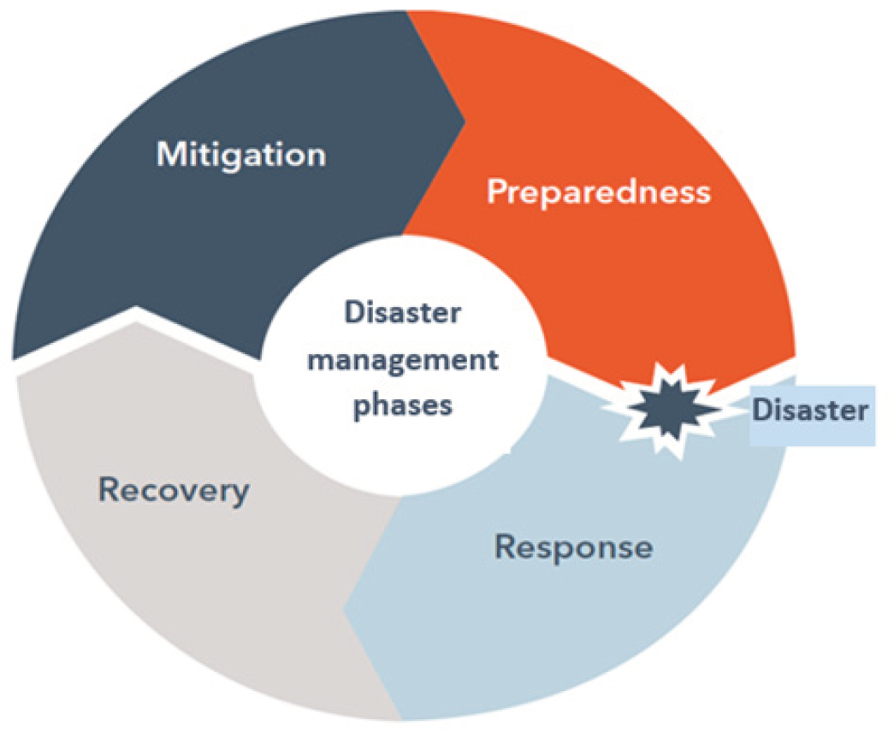
Source: ITU (2020)

Mitigation
The mitigation phase seeks to carry out actions that aim to prevent a disaster, reduce the probability of its occurrence, and limit the negative effects of unavoidable threats. This phase includes activities such as identifying existing hazards and risks, telecom/ICT vulnerability assessments, the construction or maintenance of critical telecom/ICT infrastructure, and the development of written plans and procedures, such as the NETP.
During this phase, the role of telecom/ICTs is to help analyse the risk of potential disasters, disseminate information about impending hazards and on how to mitigate its impacts so that hazards do not lead to disasters, identify communities at risk, and to help implement strategies, technologies and processes that can reduce those negative effects. Activities carried out during the mitigation phase include establishing legal and regulatory frameworks that support the use of emergency telecom/ICTs, conducting risk analysis of critical telecom/ICT network infrastructure, taking steps to reduce the vulnerability of telecommunications networks and improve their capacity of recovery, and assess vulnerabilities to develop multi-hazard early warning systems with the appropriate technology for each case. These strategies should be implemented before and after the emergency.

Preparedness
The preparedness phase includes the planning and preparations necessary to respond to a disaster event. These include the establishment of multi-hazard early warning systems, training, operational processes, and the implementation of those written plans and procedures developed during the mitigation phase.
Telecom/ICT networks and services in this phase are essential to facilitate the dissemination of information, educational campaigns and alerts so that the public is aware of the actions they must take during an emergency. Likewise, they must facilitate the coordination and communication of national entities involved in disaster risk management.
During this phase, it is important to make and implement plans to guarantee that communications will not be interrupted, to continuously carry out telecom/ICT training and drills, and to regularly carry out activities designed to create awareness among those involved, including campaigns in different formats accessible to the entire population regarding potential hazards and the activities that people must carry out once a disaster strikes.

Response
The response phase is carried out during the emergency itself and includes humanitarian activities such as search and rescue, the evacuation of people from affected areas, the opening of shelters, among others.

The role of telecom/ICTs networks and services during this phase is vital for connecting stakeholders, such as first responders, government agencies, communities at risk, shelters, health centres, and Non-Governmental Organizations (NGOs), among others. This is especially important considering that several entities carry out a variety of activities and procedures at the local, national, and international level.

Recovery
The recovery phase of the weeks and months after a disaster focuses on providing necessary aid to restore to the community the pre-disaster levels of safety and functionality as a minimum, but ideally should improve on that standard by “building back better”. Activities during this phase include (but are not limited to) infrastructure reconstruction, restoration of public sector operations, and debris removal. This restoration and reconstruction must include telecom/ICT infrastructure, given the fundamental role that the sector plays within the community.

Early Warning for All Initiative (EW4ALL)
In March 2022, the UN Secretary-General launched the EW4All initiative, to ensure that everyone on the planet is protected from hazardous weather, water or climate events through early warning systems by the end of 2027. The initiative is co-led by the World Meteorological Organization (WMO) and the United Nations Office for Disaster Risk Reduction (UNDRR), with support from the International Telecommunication Union (ITU) and the International Federation of Red Cross and Red Crescent Societies (IFRC) as well as other partners.
The EW4All initiative considers 4 key Multi-Hazard Early Warning System (MHEWS) pillars (see Figure 2 below):
- Disaster risk knowledge and management: Aims to collect data and undertake risk assessments to increase knowledge on hazards and vulnerabilities and trends. It is led by UNDRR with support from WMO.
- Detection, observations, monitoring, analysis and forecasting of hazards: Seeks to develop hazard monitoring and early warning services. It is led by WMO, with support from UN Development Programme (UNDP), UN Educational, Scientific and Cultural Organization (UNESCO), and UN Environment Programme (UNEP).
- Dissemination and communication: Focus on communication of risk information so it reaches all those who need it, in an understandable and usable way. It is led by ITU, with support from IFRC, UNDP, and WMO.
- Preparedness and response: Seek to build national and community response capabilities. Led by IFRC, with support from Risk Informed Early Action Partnership (REAP), Office for the Coordination of Humanitarian Affairs (OCHA), Food and Agriculture Organization (FAO), and World Food Programme (WFP).
In November 2022, an Executive Action Plan was launched to implement this initiative. The Plan establishes the different outcomes and activities to carry out to effectively implement the initiative in each of the 4 pillars.

Early Warning Systems (EWS) under the EW4All initiative is a key outcome of this National Emergency Telecommunications Plan (NETP). It will be a key implementation activity for the The Gambia Government going forward, which may lead to further framework changes as the implementation of an EWS is progressed.

Figure 2 - Pillars of the EW4ALL Initiative
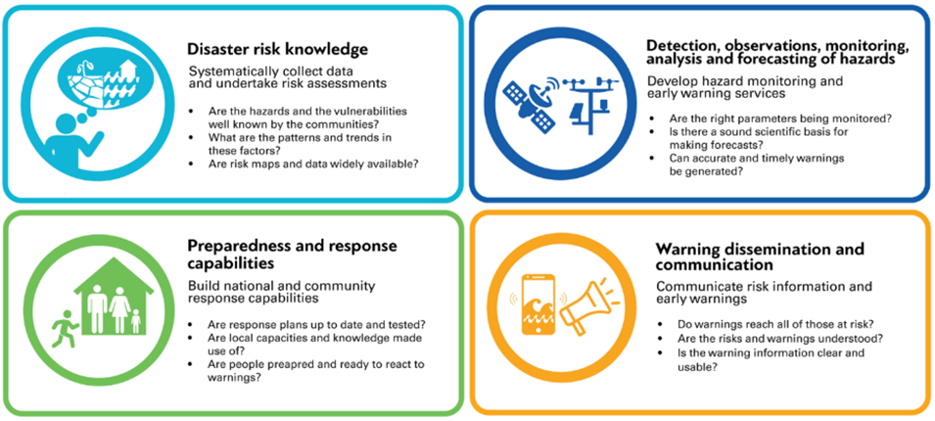
The first pillar focuses on enhancing global risk knowledge and integrating it into inclusive, accessible, and effective early warning systems. This is relevant considering that significant gaps in terms of risk information and assessments persist worldwide, as less than half of the countries with existing Early Warning Systems (EWS) have access to appropriate disaster risk information, and even fewer have national legislation and regulatory frameworks for emergency response. To address this, the Executive Action Plan proposes activities that include the following
- Significantly strengthens the ability of countries to produce national, sub/national, and local risk information, integrating existing community knowledge, to a defined minimum capability (vulnerability, exposure, hazard).
- Ensure that countries have access to open and relevant risk data, metrics, and analysis to support decision-making.
- Develop institutional capacity to incorporate risk knowledge into early warning systems.
- Define roles/responsibilities and, in general, strengthen the collaboration between key Ministries, academia, the private sector and vulnerable communities to generate improved risk information.
- Ensure that all risk knowledge capability is locally led, where possible, people centred and strengthened through an increased use of science.
For the second pillar (Observation and Forecasting for Early Warnings), the Action Plan centres in five key action areas, which are:
- Enhancing capacity to detect hazards: The Action Plan proposes to conduct gap analyses on early warning needs, expand the cataloguing of hazardous events, an enhance the timely access to, and use of satellite observations and of advanced technologies to build up detection and forecasting capabilities.
- Close the observing gaps to meet the data needs for monitoring hazards, including actions such as establishing and implementing the Global Basic Observing Network to deliver timely data to global weather prediction systems, and accelerating the implementation of the WMO Action plan for hydrology, including establishing regional hydrological status systems (HydroSOS).
- Enhance the existing framework and the capabilities of global data processing, forecasting, and analysis systems: this includes the expansion of the network of Regional Specialized Hydro-Meteorological Centres and the associated National Hydro-Meteorological Centres to meet region specific needs.
- Sustainable data and Information exchange infrastructure to support EWS: Considers actions like accelerating the implementation of the WMO Information System 2.0 (WIS 2.0) to enable timely and sustained data access and develop technical capabilities.
- Optimize international efforts on observation, monitoring, and forecasting in support of EWS, as fostered by, for example, UNDP, UNEP and UNESCO, and upscale successful regional initiatives on sharing data and forecasting products.

Pillar 3 of the EW4All initiative (Warning Dissemination and Communication) is led by the ITU with support from IFRC, Risk-informed Early Action Partnership (REAP), UNDP, and WMO. It focuses on ensuring that an identified risk and alert can reach those people at risk, including that the alert message is communicated and formulated in a way that those who receive it can understand and act on the alert, using a standardized and consistent format such as Common Alerting Protocol (CAP).
In this third pillar, ITU highlights the use of multichannel dissemination alerting (including radio, TV, sirens, Internet, social media, etc.) and the opportunities that the spread of ICTs provide in reaching more people (i.e. increased mobile broadband networks and ownership of mobile devices). One key advantage of disseminating alerts through mobile networks is that these networks are geo-located, so warnings can reach only those users located in a specific risk zone. Also, this communication technology (called cell-broadcast, and often complimented with location-based SMS) allows for warnings adapted to specific user requirements, such as a certain language, among other possibilities (See Section 10.1.3.1 Location Based SMS (LB-SMS) and Section 10.1.3.2 Cell Broadcast (CB)).
ITU has also highlighted that the pillar will focus on promoting a regulatory approach, based on the model adopted by several countries including the EU, which has mandated the use of geo-located alerts using mobile networks, and engaging the mobile network operators to implement mobile EWS systems.
According to the EW4All Executive Action Plan, expected outcomes for the third pillar include:
- Define functions, roles, and responsibilities for each actor in the warning dissemination process through government policy.
- Ensure that warnings reach those at risk by using multichannel dissemination and communication alerting.
- Strengthened and expanded alert dissemination and feedback channels reaching all people with actionable information.
- Ensure the capability for effective, authoritative emergency alerting that leverages the Common Alerting Protocol (CAP), suitable for all media and all hazards.

Finally, the fourth pillar relates to preparedness to respond, and focuses on the different actions to be taken to ensure that early warnings result in reduced losses and harm. That is, from people at risk being prepared and able to respond to a warning themselves, to national and local stakeholders having their capacities strengthened for when required. According to the Action Plan, the main outcomes in this pillar include:

- Crisis/disaster risk management and climate adaptation laws, policies and/or plans are reviewed, ensuring they reduce climate change impacts and exposure on people and the environment.
- Preparedness capacities are ensured at the local level, enabling local first responders to act quickly and effectively based on the early warning alert.
- Countries and local actors can monitor the availability of early warnings, associated financing and the feasibility and effectiveness of anticipatory action.
- Strengthened collaboration between stakeholders for informed action on the ground.

Legislation, Policies and Plans Related to Disaster Risk Management
In case these are not currently in place, high-level laws and regulations for DRM should be established. This comprehensive legal, policy, and institutional framework should be based on the existing DRM policy and include national disaster management plans and be specific in defining the agencies accountable for developing emergency sectorial regulations.
To be updated following stakeholder consultation
Legislation and regulation are key tools for disaster risk management, as they are the foundation for the definition of roles and responsibilities of all actors involved in the disaster management process. Laws and regulations are the framework upon which coordination mechanisms, communication channels and standard operating procedures are determined, and upon which decision makers in relevant agencies are identified.
Thus, it is important to confirm and assess the current legislative and regulatory framework for Disaster Risk Management (DRM) and Disaster Risk Reduction (DRR) in The Gambia. This framework is described in more detail in the following sections.

National Disaster Management Policy 2007
The National Disaster Management Policy (NDMP) seeks to outline and develop adequate capacity for co-ordination and co-operation in disaster management across key stakeholders at all levels. The policy considers the disaster management from a development perspective and as such mainstreaming disaster management activities is an integral part of the development process.
The objectives of the Policy are to:
- To integrate disaster risk reduction into sustainable development policies and planning.
- To develop and strengthen institutional mechanisms and capacities to build resilience to hazards.
- The systematic incorporation of international, regional, national and local disaster risk reduction strategies and approaches into the implementation of emergency preparedness, response and recovery.
- To achieve a comprehensive, all hazard, all agencies approach by achieving the right balance of prevention, preparedness, mitigation, response and recovery.
- Prepare communities to ensure that they are fully equipped to anticipate and respond to disaster events.
- To promote a transparent, systematic and consistent approach to disaster risk assessment and management.
- A multi-stakeholder participatory approach including community participation at all levels.
- Develop a database and information exchange system at national and international levels.
The Policy is a concise document that considers key DRM focus areas such as;
- Making disaster risk reduction a development priority
- Improving early warning systems
- Addressing priority development concerns to reduce underlying risk factors
- Effective disaster response through disaster preparedness.
The Policy also considered the framework that is to be established to manage DRM in The Gambia which is shown Figure 3 below.
Figure 3 - The Gambia Disaster Management Framework
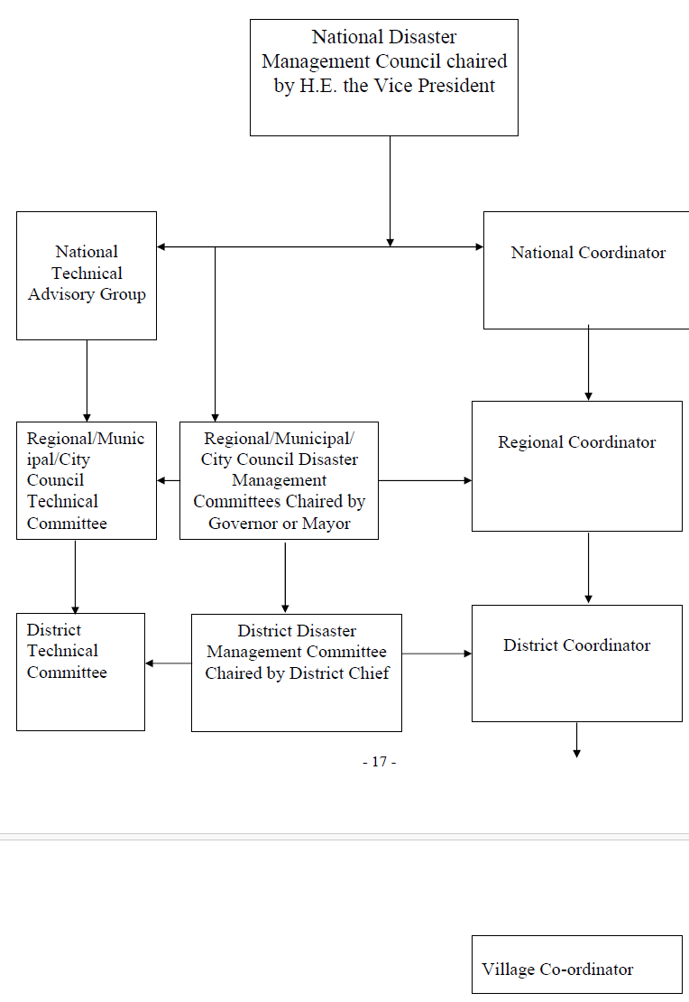
There does not currently appear to be any updated policy document.

The National Disaster Management Act, 2008
The National Disaster Management Act, 2008 (the Act) provides for “an integrated and coordinated disaster management that focuses on prevention, preparedness, response, mitigation, and recovery from, disasters or emergency situations, and the management of their effects, to establish a National Disaster Management Agency and Regional, District and Village Disaster Management Committees and for matters connected therewith”. The Act provides the legal framework for the co-ordinating structures recommended in the NDMP.

The Act aligns with the National Disaster Management Policy 2008 and formally establishes the National Disaster Management Council (NDMC), a Technical Advisory Committee and the National Disaster Management Agency (NDMA) under the Office of the President (OP) and tasks the NDMA with being the national focal point for the co-ordination of Disaster Risk Reduction and Management (DRRM) in The Gambia. Other salient responsibilities of the NDMA are

- Lead the country’s efforts to prepare for, respond to, recover from, and mitigate the risks of natural and man-made disasters.
- Establish and maintain relations with international relief organizations in order to facilitate accessing of their resources in the event of a disaster.
- Coordinate requests for aid, and to control and direct the allocation of aid provided by government and non-government agencies.
- Advise and brief the NDMC from time to time on progress and major problems in disaster management, and if appeal for international assistance is required.
- Act as the central planning, coordinating and monitoring institution for disaster management and post-disaster recovery reconstruction.
- Prepare, update, maintain, implement and monitor the National Disaster
- Plan; and
- Lay down guidelines for the Regional Committees and District Committees in drawing up the Regional Disaster Plans and District Disaster Plans, as well as advise the sector Ministries on disaster-related issues.
The Act also establishes Regional, District and Village Disaster Management Committees to oversee local civil protection and operations during a disaster.

Disaster Declaration or State of Public Emergency
The ACT provides the President of The Gambia with the power to declare a State of Emergency. The Act notes that the Presidente must be satisfied with the advice of the NDMC with respect to the calling of a State of Emergency.

National Disaster Fund
The Act requires the NDMA to establish the National Disaster Fund, designed for the purpose of a contingency fund for the development and promotion of DRM as well as provision of commodities and relief as part of a disaster situation in The Gambia.

Customs and Excise Act
There are no specific provisions under the National Disaster Management Act relating to customs arrangements and these arrangements for the importation of relief goods may be governed by the Customs and Excise Act 2010. The Customs and Excise Act 2010, provides for the management of and assessment of customs duties on goods coming into the country. These duties may be waived if the Minister of Finance and Economic Affairs deems the goods in the public interest. There is no definition of “public interest” but the interpretation could be applied to disaster relief.

National Climate Change Policy
Climate change effects are evident in The Gambia, including increasing average temperatures and a rainfall regime that is decreasing in amount while increasing in variability. These changes affect the economy: increased flooding damages roads and infrastructure, decreased agricultural production reduces food security, and increasing heat and dryness threaten people’s health; and the population leading to higher levels of poverty.
This National Climate Change Policy has been developed to responded to the emerging climate threats, albeit largely through project-driven responses, given resource constraints, and within a fragmented policy context. The Policy sets in place enhanced institutional arrangements for coordination and mainstreaming, outlines a new integrated approach to resource mobilisation, and develops a clear policy direction for human resource development.
The key objectives of the Policy are:
- Advance the understanding, capacity and social empowerment of all Gambians so that they can adequately respond to climate change.
- Ensure adequate climate change research for informed decision making, and promote timely access to climate information and early warning of climate risks
- Put in place sound and equitable adaptation and mitigation measures that promote effective management of ecosystems and biodiversity, reduce vulnerability to climate change impacts, and reduce greenhouse gas emissions, to achieve sustainable low-carbon socio-economic development.
- Effectively integrate climate change into all sectors and across all scales, through mainstreaming climate risks and opportunities into national and sectoral frameworks, and through effective policy coordination and implementation.
- Build the resilience of communities and ensure health and welfare through participatory, equitable and pro-poor approaches to climate change that emphasise the meaningful inclusion of women and vulnerable groups.
- Integrate community-based adaptation with ecosystem-based approaches to strengthen people’s adaptive capacities and develop more climate-resilient livelihoods, by investing in sustainable natural resource management initiatives.
- Coordinate national and international financial resource mobilization to address climate change by mainstreaming climate finance readiness and identifying, developing and promoting innovative financing mechanisms.
There is no mention of utilising ICT in this policy. There is mention of The Gambia pursuing areas of cooperation in early warning systems and emergency preparedness.
Implementation Task 1
It is clear that, at least at this legislative and policy level, DRR has been actively considered and attempts have been made to provide for the mainstreaming of DRR at all levels in various sectors. For the most part, the legislation, policies and plans are outdated and require review and enhancement to address any shortcomings when considered against best practice examples.
The opportunities for enhancement should consider
- The role of Information Technology and Communications within the DRM framework and particularly with respect to defining and leading these sectors during a disaster situation.
- Stronger policy and regulation on the implementation of early warning systems.
- Stronger policy surrounding agencies implementing monitoring systems to ensure that the NDMA is notified of such systems.
- Clarity with respect to duty exemptions for disaster relief goods and materials
- Stronger community involvement.
- Consideration of the role of woman and those disadvantaged.
As an implementation task the NDMA should consider a holistic review of the DRM framework, legislation and policies and compare against best practice examples.

Plans, Policies and Programs Related to Disaster Management
Each Countries National Disaster Plan and National Emergency Telecommunications Plan should be developed or updated based on the legislation for DRM currently in force in each country.
To be updated following stakeholder consultation
The Gambia has no developed National Emergency Telecommunications Plan (NETP) but does have additional plans, polices and programs to assist in the DRM process. Not all have these have clearly included ICT as a critical element of DRM and DRR.

Recovery Focused National Development Plan 2023-2027
The Gambia’s Recovery Focused National Development Plan (RF-NDP 2023 - 2027) charts the recovery of the Gambia from COVID-19, climate change and other shocks. The approach used in the preparation of this plan is a “whole of society” one that articulates the medium-term transformational aspirations of the country. The plan has been formulated with consideration of global shocks including climate change. The plan therefore endeavours to build the resilience of institutions and people in responding to these and other shocks.
The goal of the RF-NDP 2023-2027 is to consolidate gains in democratic governance, accelerate green economic and social transformation and build resilience to shocks and crises. This goal will be realised through three strategic objectives:
- Strategic Objective 1 (SO1): Build household and community resilience to address shocks and crises arising from climate change, economic volatility and to counter the effects of pandemics like the COVID-19.
- Strategic Objective 2 (SO2): Consolidate gains and address critical development gaps in governance and in economic and social transformation.
- Strategic Objective 3 (SO3): Strengthen accountability, build partnerships and set up robust and sustainable resource mobilisation strategies for effective delivery of development actions and expected outcomes.
The Plan will be implemented through the following pillars:
- Pillar I: Building Community Resilience to Shocks and Crises.
- Pillar II: Governance Reforms.
- Pillar III: Macroeconomic Stability and Growth.
- Pillar IV: Human Capital Development.
- Pillar V: Agriculture, Environment, Natural Resources and Climate Change.
- Pillar VI: Empowerment, Social Inclusion and Leaving No One Behind.
- Pillar VII: Energy, Infrastructure and Information and Communication Technology (ICT)/Digital Connectivity.
Under Pillar 1 recovery and resilience are important themes. Importantly, this Pillar stipulates that a “fully integrated and effective early warning system and early response system needs to be put in place”. This system is to be implemented at national and regional levels. No time frame is given for when this is to occur.
ICT is considered throughout the Plan due to its ubiquitous use across all pillars. There appears to be no specific mention of ICT within Pillar 1.

The Gambia 2050 Climate Vision
The purpose of the 2050 Climate Vision is to provide such a roadmap which will assist the country in making the right climate related investment decisions regarding where scarce resources should be deployed. By prioritising climate related development actions, the 2050 Climate Vision will also provide a framework for responding to global disruptions. The 2050 Climate Vision serves not only as a strategy for a better future but also provides the fundamentals for current investment.
To achieve the 2050 Climate Vision, The Gambia has prioritised and organised policy commitments and actions in four strategic and integrated focus areas:
- Climate-resilient food and landscapes: Agriculture, food security, forestry and natural resources (including water, biodiversity and wildlife)
- Low emissions and resilient economy: Energy, transport, infrastructure and the key economic sectors of tourism and financial services
- Climate-resilient people: Health, education, equitable social development and human settlements
- Managing our coasts in a changing environment: Climate-aware Integrated Coastal Zone Management.
The 2050 Climate Vision does provide comment under 2.5.3 Climate-resilient people: health, education, equitable social development and human settlements that a there would be a focus on secured resilience of communities, comprehensive disaster prevention, disaster management and risk reduction, and enhanced early warning systems implementation.

National Broadband Policy 2020-2024
The Gambia’s Broadband Policy 2020 – 2024 lays down the strategic vision for a broadband that can transform The Gambia into knowledge-based economy and an information society. It outlines the national goals concerning broadband while elaborating specific policies to achieve those goals within the overarching context of ICT4 Development Master Plan.
The objective of the Policy is to recognise Information and Communication Technology (ICT) as critical enablers for the achievement of the objectives of the National Development Plan (NDP). Broadband is recognized as a key facilitator for the growth and advancement of the entire ICT sector especially in the creation of the information society.
The Policy is to enhance and improve the following:
- Contribution to Government revenue.
- Employment in the ICT sector.
- Access and usage of ICT Infrastructure.
- The Gambia’s ICT development index.
- ICT skills development.
- Application of ICT services in business and general service delivery.
- Job creation, research and development.
- National ICT capacity and industry workforce.
- The country’s information security system.
- Legal and regulatory frameworks for certitude and responsiveness.
Implementation of this policy the country will have the ability to:
- Deliver the best possible education to future generations.
- Manage healthcare in poor, ageing or isolated populations.
- Control and use energy more efficiently.
- Take better care of the environment.
- Streamline transport networks; and
- Accelerate progress towards the SDGs.
Implementation Task 2
The key implementation task from this section is the development and completion of the Namibian NETP. However, there are several other plans that are now seen as out of date and should be reviewed and brought into a best practice position.

Agencies Involved in Disaster Risk Management
Based on the general national DRM laws and regulations, the Government should define the clear responsibilities and activities for the Ministry responsible for telecom/ICT and the Telecoms NRA in each Member State.

To be updated following stakeholder consultation
This section provides an overview of the major disaster management and humanitarian agencies currently operating in The Gambia.

National Disaster Management Council
The This Council is the Governing Body of the National Disaster Management Agency. The President of the Republic of The Gambia chairs the NDMC which includes various line ministries and is the highest decision-making body on all matters of disaster management in the country. The composition and functions of the Council as stipulated in the NDMA Act 2008 are as follows:
- The President of the Republic of The Gambia as Chair
- Minister of Environment, Water Resources, Climate Change and Parks and Wildlife
- Minister of Health and Social Welfare
- Minister of Agriculture
- Minister of Lands and Regional Administration
- Minister of Fisheries
- Attorney General and Minister of Justice
- Minister of Finance and Economic Affairs
- Minister of the Interior
- Minister of Defence
- Association of Non-Governmental Organisations (TANGO) representing non state actors
- Gambia Chamber of Commerce and Industry (GCCI) representing the privates ector
- National Search and Rescue commission
- Executive Director of the NDMA as secretary to Council
The importance of ICT and its associated ministry is not apparent in the NDMA Act 2008 and any review of this Act should include this ministry particularly as the criticality of the role of ICT in the DRM ecosystem continues to grow.

National Disaster Management Agency
Under the Office of the President (OPM), sits the National Disaster Management Agency (NDMA). The objective of the NDMA is to be the coordinating body for all disaster and management and risk reduction activities. Apart from the responsibilities identified earlier (see 3.2). Furthermore, as the central planning, coordinating and monitoring institution for disaster management and post-disaster recovery reconstruction in The Gambia, the NDMA is empowered to undertake the following actions
- Coordinate the actions of Ministries, Government Agencies, Regional, District and Village Disaster Committees, Local Authorities and Non-Government Agencies.
- Cooperate with UN agencies, other international organisations and governments of foreign countries for the purposes of disaster management under this Act. Coordinate requests for aid, and control and direct the allocation of aid provided by Government and Non-Government Agencies.
- Ensure that aid for disasters is used for the purpose for which it was provided.
- Establish and maintain relations with international relief organisations to facilitate accessing of their resources in the event of a disaster.
- Mobilise and organise technical assistance from interested national and international bodies to assist in the development of disaster response capabilities of the agency.
- Provide a clearing house for relevant information and intelligence in all matters in relation to disasters including current research being undertaken in all related institutions.
- Liaise with domestic and international persons and organisations to exchange information and facilitate the harmonisation of their relevant policies with the government.

Public Utilities Regulatory Authority
The Gambian Public Utilities Regulatory Authority (PURA) was established under The Gambia Public Utilities Regulatory Act 2001 (the PURA Act). Under the PURA Act, PURA is mandated to regulate certain “regulated industries” such as communications, transport or energy that provide services directly or indirectly to the public. Further day-to-day operational activities of regulating the telecommunications market, have been clarified and set out under the Information and Communication Act, 2009, including
- Protecting the interests of consumers, purchasers, and other users of communications services.
- Promoting access to information and the development of human resources in the communications sector.
- Promoting efficiency and competition among all the entities engaged in the provision of communications; and
- Advising the government on policy issues related to the communications sector, among other responsibilities.
PURA provides statistical information on the telecommunications market in The Gambia. This provides information on key indicators such as
- Mobile subscribers
- Fixed line subscribers
- Traffic
- Revenue
- Investment
- Broadcasting services, and
- Postal services

Ministry of Communications and Digital Economy
The Ministry of Communications and Digital Economy (MoCDE) is tasked with strengthening the digital infrastructure ecosystem through policy and regulatory actions to increase the use of digital solutions in the economy for improved productivity. The Ministry has a responsibility of building and maintain the national communications infrastructure, developing enabling policy and leveraging digital technologies.
Within MoCDE resides various agencies including
- Gambia ICT Agency
- Gamcell
- Gamtel
- Gampost, and
- Digital Gambia

Gambia ICT Agency
The Gambia ICT Agency (GICTA) is the key Agency tasked with empowering Gambia’s public sector and residents with smart and innovative cutting-edge digital solutions in all spheres of the public domain that promote collaboration, efficiency, inclusion, and accessibility; leading the coordination and standardisation of the design, implementation and management of comprehensive ICT initiatives and services; and fostering digital transformation and the realisation of the digital economy.

The Gambia Meteorological Division
The Gambia Meteorology Division sits under the Ministry of Fisheries and Water Resources (MoFWR) and is the national agency for the provision of official meteorological forecasts and warnings. The MoFWR is responsible for the provision of Alerts and Warnings via Extreme Weather Reports.
The MoFWR is also the alerting authority for the operation and activation of the Common Alerting Protocol (CAP) for use in early warnings.

National Sectors
The Gambia operates a sector or cluster system. These sectors and lead agencies are identified in Table 1 below.
Table 2 – The Gambia Sector Structure
Sector |  | Lead Ministry | Co-lead

Sectors will be required to prepare standard operating procedures and annual reports, and Cluster Response and Recovery Plans before or immediately after a disaster event.
It should also be noted that many countries have a dedicated Sector or cluster for Communications generally led by the associated Ministry for Information Technology and Communications. This sector clearly just focusses on the telecommunications aspect of DRM due to the importance that telecommunications play in all phases of a disaster.

National Emergency Telecommunication Cluster
A Telecommunications Cluster will be key to facilitating the implementation of the NETP Implementation Items. The cluster must be well supported to ensure that identified gaps in The Gambia’s emergency telecommunications capacity are closed, and that cross-sector information sharing, planning, coordination and working relationships are established before an emergency.
Cluster members may/should include representatives from:
- PURA
- NDMA
- MoCDE
- MoFWR
- First Responders
- Telecommunications operators​
- Internet Service providers
- Broadcasters; and
- Others as identified

World Food Program (WFP) – Emergency Telecommunications Cluster (ETC)
The UN World Food Programme (WFP) is the world’s largest humanitarian organization. WFP is the lead agency in the International Logistics Cluster, and co-leads with FAO the Food Security Cluster. WFP also leads the International Emergency Telecommunications Cluster (ETC).
In a similar manner to the ITU, the ETC provides two basic services to countries. The first is preparedness, in which the ETC will review the preparedness of a country to provide support in the case of a disaster. The second is active participation whereby the ETC will provide equipment and expertise to a country to ensure that telecommunications services are operational as soon as possible.
At present the ETC has no active operations in The Gambia.
Implementation Task 3
Many provisions are in place within The Gambia for DRM, either in existing plans or in associated legislation and policy. However, in many cases the plans are out of date and consequently do not align with what would be considered best practice. Similarly, provisions in legislation should be clarified to clearly show those provisions that align with DRM activities.
- PURA should undertake a review of specific regulations that have a DRM aspect and consider updating these regulations to reflect best practice and explicit application to DRM. This includes
  - A review of the licensing regime should be undertaken by PURA to ensure that temporary licenses can be expedited in a disaster situation
  - A review of the any Type Approval Regulations should be considered to ensure that the importation of temporary equipment can be undertaken in a disaster situation.
- A National Emergency Telecommunications group/cluster should be established that provides input into the NETP on an ongoing basis and take part in the implementation tasks identified in the NETP
- A Terms of Reference (ToR) for this cluster including appropriate information on members should be developed as an addendum to this NETP
- The National Disaster Management Policy should be reviewed and updated, particularly regarding the Sectors and the functions associated with the cluster/sector arrangements. A clear communications sector should be implemented into this plan to show the importance and relationship of telecommunications to DRM
- Provisions identified should be clearly identified in the appropriate legislation and regulations as to their relationship to DRM.

Specific Telecom/ICT Regulatory Provisions
Based on the mandate of a high-level DRM law or policy, the responsible agency for developing regulations for emergency telecom/ICTs should make provisions for different topics related to emergency telecom/ICTs for all phases of DRM (mitigation, preparedness, responses, and recovery).
Section to be updated upon review of the draft Communications Bill 2023
A lack of detail on how the telecom/ICT sector should proceed with DRR and DRM may hamper the response from being as efficient and timely as it could be regarding international emergency telecommunications assistance, as well as regarding the actions of local service providers.
PURA was established under The Gambia Public Utilities Regulatory Act 2001 (the PURA Act). Under the PURA Act, PURA is mandated to regulate certain “regulated industries” such as communications, transport or energy that require licenses and provide services directly or indirectly to the public. Given this to establish, install operate or maintain a communication system, or provide service or install a communications apparatus a license in accordance with the IC Act is required.
One of the key functions of PURA is to manage the utilisation of the radio spectrum and under the Information and Communication Act, 2009 (the IC Act) PURA is vested with the legal ownership of the radio frequency spectrum. Radio spectrum and radio systems are important components of communications during a disaster event.
An aspect of disasters is the ability for international partners and countries to come together and work together. This may also involve those partners importing equipment that they are familiar with and wish to utilise on scene. First responders rely heavily on radio networks and the underlying spectrum.
A similar situation applies whereby to operate infrastructure in the radio spectrum, an authorised license is required. Therefore, PURA under the IC Act, may
- Grant licences for the temporary provision of communications services.
- Grant licenses for the temporary use of radio frequency spectrum.
- Waive Type Approval requirements on an as needed basis
There appear to be no implicit provisions in the IC Act for expediting of emergency or disaster communications. This can be done but must be done in consultation with the Minister responsible which may induce delays. Ideally the IC Act should include these provisions explicitly.
Apart from the day-to-day operational activities of regulating the telecommunications market, PURA under the IC Act, has several provisions that can be bought to bear in the case of a disaster situation. These provisions are
- Ensuring licensees provide access to emergency service calls
- Ensure that these calls to emergency service numbers are routed for free
- The use of short codes for emergency calling
Nonetheless, apart from the above stipulations, there are no additional provisions regarding emergency telecommunications noted according to the IC Act. In particular, the IC Act does not specifically mandate PURA to develop a comprehensive regulatory framework related to telecom/ICTs for DRM.
It could be considered that PURA should be held accountable by law for establishing a regulatory framework that includes all the necessary provisions for each of the four phases of disaster risk management for the telecom/ICT
For discussion of the regulatory issues regarding international emergency telecommunications assistance, please see Section 9.1 Tampere Convention
Implementation Task 4:
The Public Utilities Regulatory Authority (PURA) is responsible for establishing specific regulations for the telecom/ICT sector on disaster risk management. These regulations should be based on its functions granted by legislation, encouraging telecom/ICT network and service providers to actively participate in each of the phases of disaster risk management. Consequently, PURA should review and enhance the regulatory framework that facilitates the use of telecommunications resources in each of the phases of disaster management for the local telecom/ICT services sector.
PURA should undertake a review of specific regulations that have a DRM aspect and consider updating these regulations to reflect best practice and explicit application to DRM. Areas that could be addressed include (but are not limited to) those presented in the following sections.
- Mitigation and Preparedness Phases
- Oblige telecommunications service providers to carry out vulnerability analyses of their networks according to risk maps of different geographical areas and to establish corresponding contingency plans that guarantee, to the extent possible, vital communications for emergency management and disaster risk reduction, as well as the timely restoration of user communications. These plans should be submitted to and approved by PURA.

- Ensuring that the associated legal instruments have explicit wording to ensure that temporary arrangements for spectrum licenses, operational licenses, type approvals or other such matters can be expedited in a disaster situation without Ministerial consent.

- Require that radio and commercial broadcasting operators, public and private television broadcasting operators, as well as civil society entities with assigned radio frequencies, transmit information campaigns for the mitigation of disasters and emergencies. These campaigns should be developed in coordination with NDMA and the PURA and should have a regulated duration and broadcasting timeline.

- Require that radio and commercial broadcasting operators, public and private television broadcasting operators, as well as mobile providers, disseminate CAP alerts to inform the population of a hazard accurately and in a timely manner.

- Response Phase
- Ensure that providers of commercial fixed and mobile telecommunications services take the necessary measures to make available their networks and sufficient capacity for communications to the authorities and affected population, free of charge and in a timely manner, as soon as a disaster situation or emergency is declared.

- Require providers of commercial mobile service to encourage their customers to send SMS messages instead of other means of communication such as voice or data services, to avoid network congestion. Also, require that commercial telecommunications, fixed and mobile service providers, to limit the duration of calls to, for example, a maximum of 2 minutes in the geographic area of ​​the disaster for a period of 12 hours following the event that generates the emergency. These norms would not apply to calls made from or to the numbers of the authorities involved in the emergency response.

- Ensure that providers of commercial fixed and mobile telecommunications services give priority in communications to calls made by the authorities for a period of 24 hours after the emergency is declared, extendable as decided by the responsible authority (e.g. DMD).

- Oblige radio broadcasting, commercial and community operators, as well as public and private television broadcasting operators, to transmit messages from DMD to inform and update the public about the disaster. These messages could include helpful content regarding health services, shelter, food, and family reunification, among others.

- Oblige telecommunications service providers to immediately assess the damage to their networks and implement the previously prepared contingency plans, to re-establish communications as soon as possible. The different government entities, through the PURA, should support and facilitate the implementation of those contingency plans.

- Recovery Phase
- Require commercial and telecommunications service providers to re-establish permanent solutions to restore and improve communications to end users, with the aim of building back better, in alignment with the Sendai Framework.

Mitigation Phase

Vulnerability to Disasters from Natural Hazards in The Gambia
The Gambia should maintain updated vulnerability maps for the different types of hazards in the NETP and especially those related to droughts, floods, and epidemics.

Overview
The Gambia is exposed to a range of different hazards, including floods, heavy storms, droughts, dry spells, strong winds and cyclones, epidemics, wildfires, and to a lesser extent, landslides, and earthquakes. The most common, nonetheless, are weather-related hazards, such as flooding and droughts, which are becoming more frequent and less predictable because of climate change.
Between 1910 and 2024, The Gambia has experienced 31 disasters, the majority produced by natural hazards, with floods being the most common type (11), followed by drought (9) and storms (6). These disasters have caused the death of over 400 people in total, more than half because of epidemics. Table 2 below provides a summary of natural hazards faced by The Gambia.
However, it is likely that due to climate change there is a higher possibility of more damaging events such as the impacts of cyclones which bring larger storm surges and more rain, coupled with sea-level rise and coastal flooding and inundation events in the future.
Table 3 – Natural Disaster in The Gambia 1920 - 2024

Flood
Floods in The Gambia effect on average approximately 7,000 people every year, with the impact felt along the western coast and river mouth. Floods are driven by climate change, and it is likely that flood events will occur with increasing frequency. As this increases the expected losses to both the economy and the impact to the population will increase in proportion.

Drought
Due to the low precipitation rate, drought is a common disaster experienced in The Gambia. Drought impacts more people than all other disasters (on average 350,000 people per year), not only from the inability to produce agricultural products, but the impact that a drought can have on food security. Drought does have a long period of establishment and once breaks can roll into a flood disaster due to dry ground and the inability of water to drain away.

Vulnerability Maps
There does not appear to be a centralised owner of this information, which is critical for the various sectors to be able to contingency planning on critical infrastructure in areas of known high hazards. Nevertheless, there has been work produced on many models and hazard-specific maps for The Gambia, however the detail and ability to overlay other maps onto them is limited.
For example, Figure 4 below shows the hazard map for river floods in The Gambia.
Figure 4 – The Gambia River Flood Hazard Map
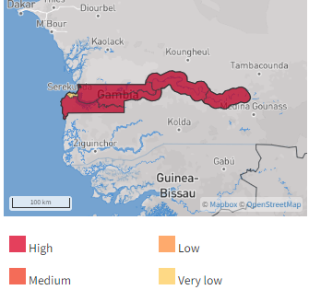
Figure 5 below shows the hazard map for drought.
Figure 5 – The Gambia Drought Hazard Map
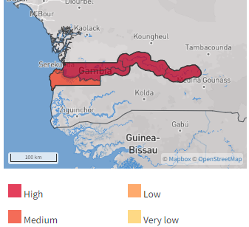
This significance of such modelling and mapping of hazards is clear and the lack of multi hazard vulnerability analysis leads to a gap in understanding the impacts of natural disasters. Vulnerability analysis and the understanding of hazards is also Pillar 1 of the UN Early Warning for All initiative. Early identification of infrastructure located in hazard zones is critical to building resilience.

Critical Infrastructure Vulnerability Analysis
In a similar manner to hazard vulnerability analysis, telecom/ICT network operators and service providers in The Gambia must develop and present a vulnerability analysis of the critical infrastructure of their networks, including coverage maps of their networks, based on risk maps of the different hazards as outlined earlier.
Understanding how exactly and to what extent infrastructure assets are likely to be affected by climate change or natural disasters requires a thorough engineering analysis of infrastructure impacts from a specific event.
In general, Table 3 below shows a World Bank assessment of the potential impact of climatic events on telecommunications infrastructure.
Table 4 - Hazard Effects on Telecommunications Infrastructure
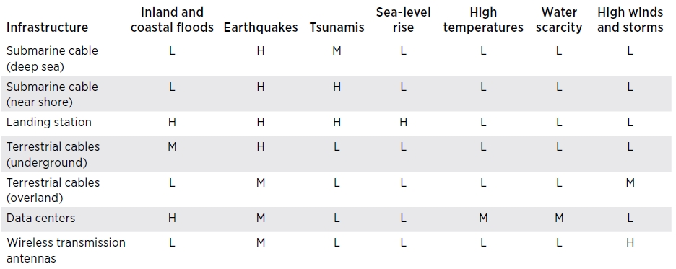Note: H: High; M: Medium; L: Low.
Landing stations are particularly vulnerable to flooding because of the large quantities of ICT equipment involved in their operations. As a result, submarine cable landing stations are the most vulnerable to a rise in sea level.

There is an average of over a hundred breaks of submarine cables every year, sometimes because of earthquakes or tsunamis, many caused by events other than natural hazards. Fishing trawlers or ships dropping anchor can damage the cables and account for about two thirds of all subsea cable breaks.

The most recent break of the ACE, West Coast of Africa (WACS) MainOne and Sat3 and the impact these breaks had on countries including The Gambia, highlights the importance of understanding the vulnerability of this critical infrastructure and what actions can be taken to mitigate or recover from the impact quickly.
Implementation Task 5
Maintaining and ensuring hazard maps for the different types of hazards that exist is an essential contributor to disaster planning and the development of mitigation strategies.
- The NDMA should lead, develop and approve updated vulnerability maps for the different types of hazards, and especially those related to droughts, floods, and epidemics developed and maintained by the relevant agencies involved in assessing and monitoring natural hazards in The Gambia.
- This information must be described at the municipal level and be available to telecom/ICT operators. It should also include information on the most vulnerable communities, specifying the type of hazards they are prone to, as well as the telecom/ICT resources available for each of them.
- PURA should ensure that all telecom/ICT service operators, mobile, fixed, and radio and television broadcasting operators, as well as government networks, in conjunction with PURA, should develop (or update) and present for approval a vulnerability analysis of the critical infrastructure of their networks, including an inventory of the infrastructure, and power, maintenance and connectivity evaluations along with consideration of the risks associated with cybersecurity (to obtain the cooperation of private, commercial entities, (it may be necessary to put in place confidentiality or non-disclosure agreements).
- This activity could be carried out with the support of the academic institutions and relevant planning departments and go beyond any current practise of collating information to become more proactive curation of data, identifying gaps and driving project requirements to expand and maintain GIS/Hazard Map information.

Telecom/ICT sector in The Gambia
All telecom/ICT service operators, mobile, fixed, and radio and television broadcasting operators, as well as Government networks, in conjunction with the NRA should develop (or update) and present for approval to the DRM Authority a vulnerability analysis of the critical infrastructure of their networks.
To be updated following stakeholder consultation
This section describes the context of the telecom/ICT sector in The Gambia and its main actors. This is an important part of the NETP; therefore, it should be updated at least every 2 years.

Overview
The telecommunications Industry in The Gambia is competitive, with a modern and extensive network coverage. The basic features of the market are:
- Open market, with an independent regulatory authority
- Four (4) mobile networks: Gamcell, QCell, Africell and Comium
- A single fixed line provider: Gamtel
- Eight (8) ISP’s across The Gambia
- One international subsea cable landing: Africa Coast to Europe (ACE)
As is the case in many small and/or developing economies, the market is dominated by prepaid subscribers. In The Gambia, prepaid makes up an estimated 92% of the market with a significant proportion of these connections in rural areas.
Table 5 – The Gambia Telecom Statistics
Key Indicators | ITU 2022, PURA 2021
Mobile Network Coverage
Mobile-cellular network (of any type) coverage (% of population) | 98.1
3G coverage (% of population) | 88
4G coverage (% of population) | 55
5G coverage (% of population) | 0
Mobile Usage
Number of mobile network operators (MNOs) | 4
Unique mobile subscriptions (2021) | 2,803,920
Mobile subscriber penetration rate (% of pop) | 113
Pre-paid connections (% of all mobile connections) | 96
Mobile broadband sub penetration rate (% of pop) | 60.1
Other Internet Usage Statistics
Individuals using the Internet (%) | 54.2
Households with a laptop/desktop computer or tablet (%) | 18.9
International bandwidth per user (kbit/s) | 93
Number of Internet service providers (ISPs) | 8
Number of Internet Exchange Points (IXPs) | 1
Fixed Broadband | % of Total
Fixed broadband subs as % of population | 0.216
Fixed Line Subscribers
Fixed line sub penetration rate (% of pop) | 2
Social Media Use
Active social media users (% of pop) | 14.4
Facebook users (% of pop) | 14.4
Instagram users (% of pop) | 5.4
Twitter (X) users (% of pop) | 1.3

Domestic Networks Overview
Domestic networks are those networks available for use within the borders of The Gambia. These networks include
- Backhaul networks
- Access networks
- Mobile networks

Backhaul Networks
Backhaul networks within The Gambia utilise both the ECOWAS Wide Area Network (ECOWAN) and the National Broadband Network (NBN) and are predominantly a combination of terrestrial fibre networks and microwave services. The backbone network is provided as an open wholesale network managed by Gamtel. According to ITU’s Connectivity Infrastructure Maps, there is little data on infrastructure in The Gambia, with a figure of over 500 kilometres of operational terrestrial fibre and no data for operational microwave networks. The connectivity maps do provide some information, and it is expected that both fibre and microwave services are used across the country, so it is important to clarify and update this information.
The Ministry of Communications & Digital Economy in a recent achievement infographic identified over 947 kilometres of fibre associated with ECOWAN and a further 420 kilometres associated with the NBN for a total of 1,367 kilometres of fibre.
ECOWAN as shown in Figure 6 below, is a national telecommunications backbone completed in 2013 forming a loop around The Gambia. The network is implemented along the main highways of The Gambia and is designed with self-healing loops to minimise failures. Where, locations cannot be economically connected to the fibre, high-capacity radio links are utilised.
Figure 6 – ECOWAN Infrastructure Map
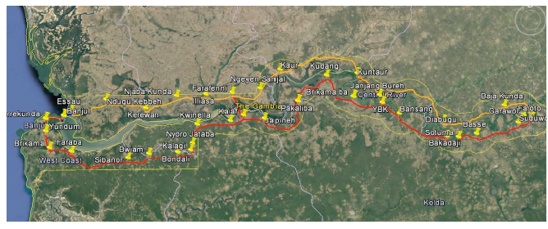
Figure 7 below provide a diagrammatic overview of the main fibre backhaul routes across The Gambia as shown in the ITU Connectivity Infrastructure Map. It can also be seen from Figure 7, the main terrestrial routes providing entry and egress to The Gambia (north and south of Banjul and the far east of the country) through Senegal.
Figure 7 – The Gambia Terrestrial and Subsea Fibre Infrastructure Map
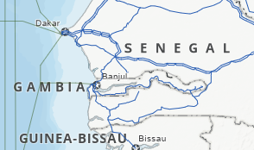
Figure 8, below shows the documented microwave transmission links in The Gambia.
Figure 8 – The Gambia Microwave Infrastructure Map
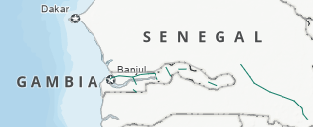

Access Networks
With Gamtel being the only fixed line provider, there are limited copper and/or fibre access networks in The Gambia, with these being in major population centres. Most access networks are via the mobile network which is typical in developing telecommunications markets. Much of the access network is used to provide connections to mobile base stations to support the provision of voice and data services over mobile phones. However, these access services can also be fibre to the premises, ADSL and Fixed Wireless Access (FWA) services which support fixed broadband services to subscribers.

Mobile Networks
The Gambia has four mobile network companies currently operating in multiple frequency bands (900, 1800, and 2100Mhz) providing services across 2, 3 4 and 5G technologies. These operators, Gamcell, Africell, QCell and Comium provide coverage to 98% of The Gambia’s population with approximately 90% covered by 4G technologies. Two MNO’s, Africell and Qcell hold over 94% of all subscribers with Africell the dominant MNO with over 63% of the market.
There is a lack of public information with respect to mobile coverage for each of the operators on their respective websites. Some information is available on the GSMA Network Coverage Maps website and other information on coverage can be sourced through third party crowd source information, but this does not show the extent of coverage for the MNOs. Figure 9, Figure 10 and Figure 11 below show combined coverage for all network types for three of the carriers from the GSMA.
Figure 9 – Gamcel Combined GSM and 3G Network Coverage
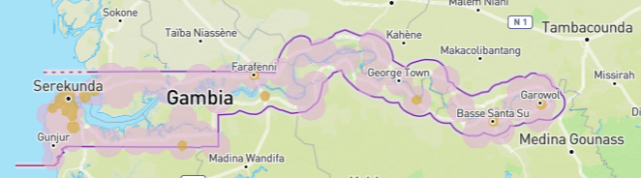
Figure 10 – Africell Combined GSM, 3G and LTE Network Coverage
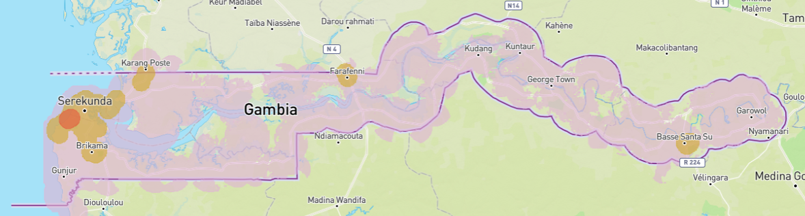
Figure 11 – QCell Combined GSM, 3G and LTE Network
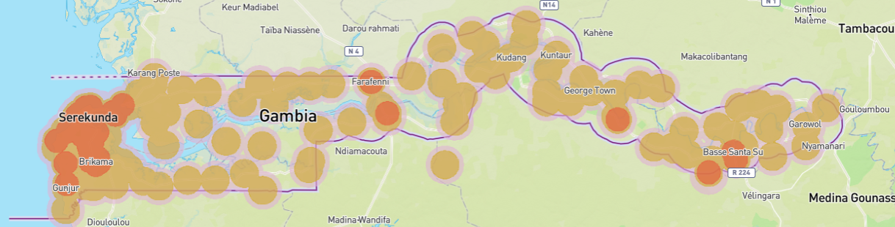
It is possible to obtain a real-world coverage analysis through crowd sourcing of data. In this case Figure 12 below shows an example of crowd sourced data for Comium, which is not available on the GSMA website. Similar data for the other three carriers is also provided. The limited data may not be that useable in a disaster scenario.
Figure 12 - Crowdsourced Coverage - Comium
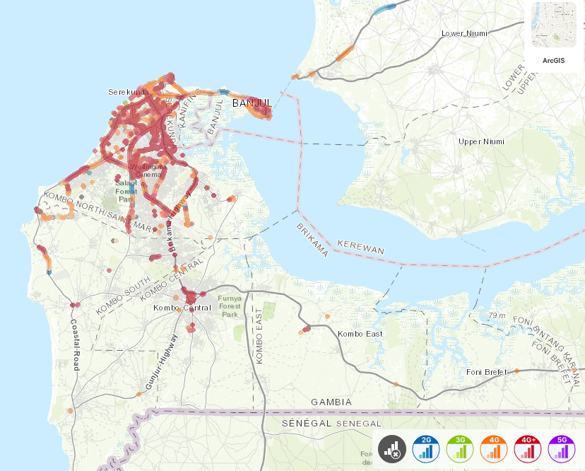
Figure 13 - Crowdsourced Coverage Data - Gamcel
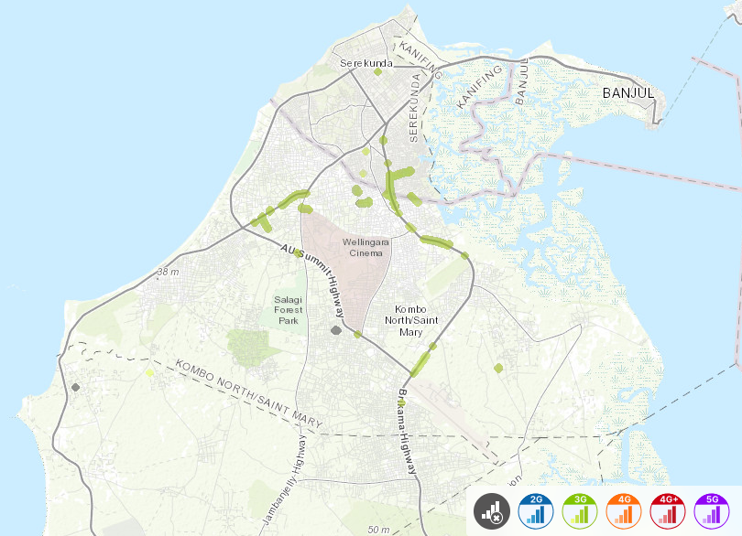
Figure 14 - Crowdsourced Coverage - Africell
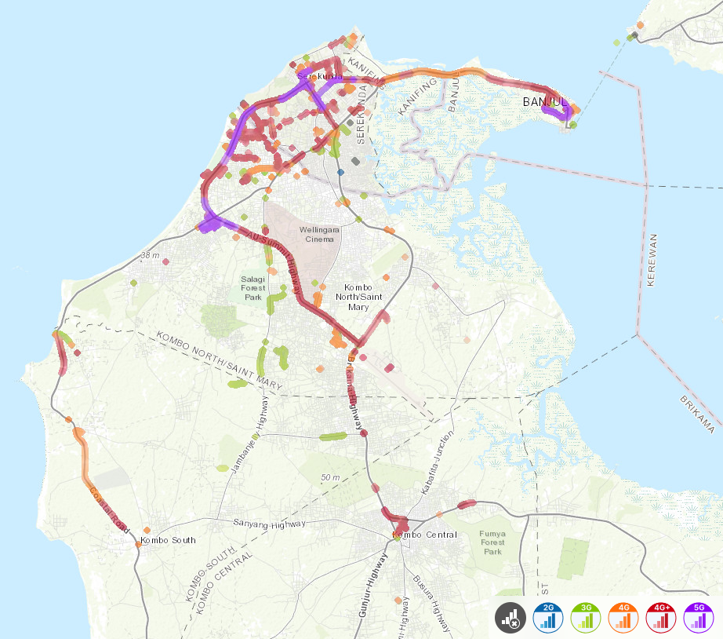
Figure 15 - Crowdsourced Coverage - QCell
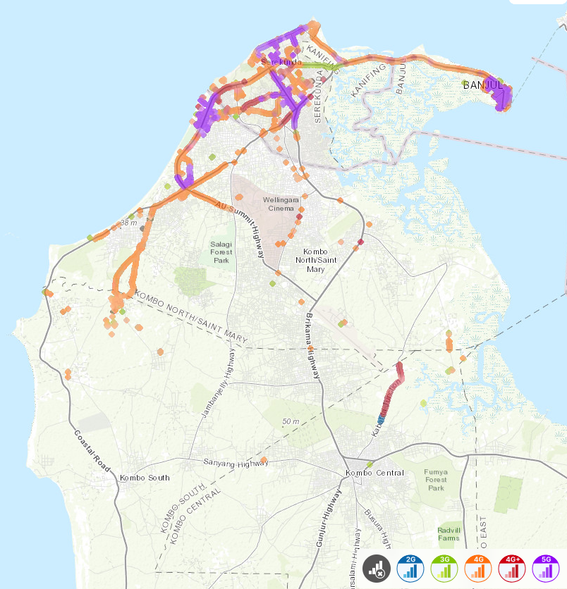

International Connectivity - Submarine Cables
The Gambia is supported by a single submarine cable: the Africa Coast to Europe (ACE) submarine cable. This cable lands in the coastal town of Banjul in a single cable landing stations as shown in Figure 16.
Figure 16 – Africa Coast to Europe Route
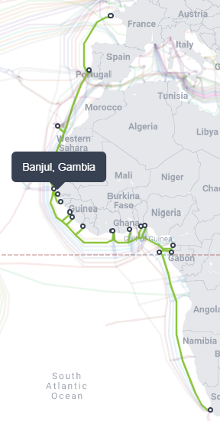
The ACE cable has been operational since 2012 with a design life out to 2034 and is consortium owned by multiple telecommunications company, including The Gambian Submarine Company. Figure 16 above, shows the route of the ACE cable with connections from Europe down the West African coast to South African. The ACE cable has a design capacity of 12.8Tbps and a lit capacity of 1.6Tbps in current use. The ACE cable provides voice and data services and connectivity to the internet.

Cable Breaks
Cable breaks are common on sub-sea cables and the recent break of the ACE cable in May, cut off much of the telecommunications services internationally, along the west coast of Africa. In the event of such a disaster, alternative routes via alternative services and solutions will be required. Consideration of greater redundancy and resilience may be needed to ensure continuous telecommunications services to the country. The Gambia is progressing with a second subsea cable to address the lack of resilience in this area.

International Connectivity - Satellites
Satellites have played an important role in telecommunications in Africa and were the only solution for telecommunications services into and out of many countries before connectivity via subsea cables.
Different private companies such as Intelsat, SES and Eutelsat offer data transmission services and Internet access through various satellite technologies. These service offerings vary in different speed ranges according to each provider, which mainly use frequency bands C, Ku and Ka, and have coverage up to the entire national territory.
Services provided from these satellites can include:
- Very Small Aperture Terminal (VSAT) data and internet services
- Voice and data backhaul
- International trunking
- Broadband Global Area Network (BGAN) services
- Maritime and aviation safety
- Television (commercial and PayTV) and radio broadcasting.
Across Africa, many countries have their own satellite systems that provide both telecommunications and broadcast services as well as earth observation data. Some of these countries, such as Angola on Angosat1, may provide temporary bandwidth in the event of a disaster. Figure 20 below shows the satellites operated by African countries.
Figure 17 - African Satellites by Country
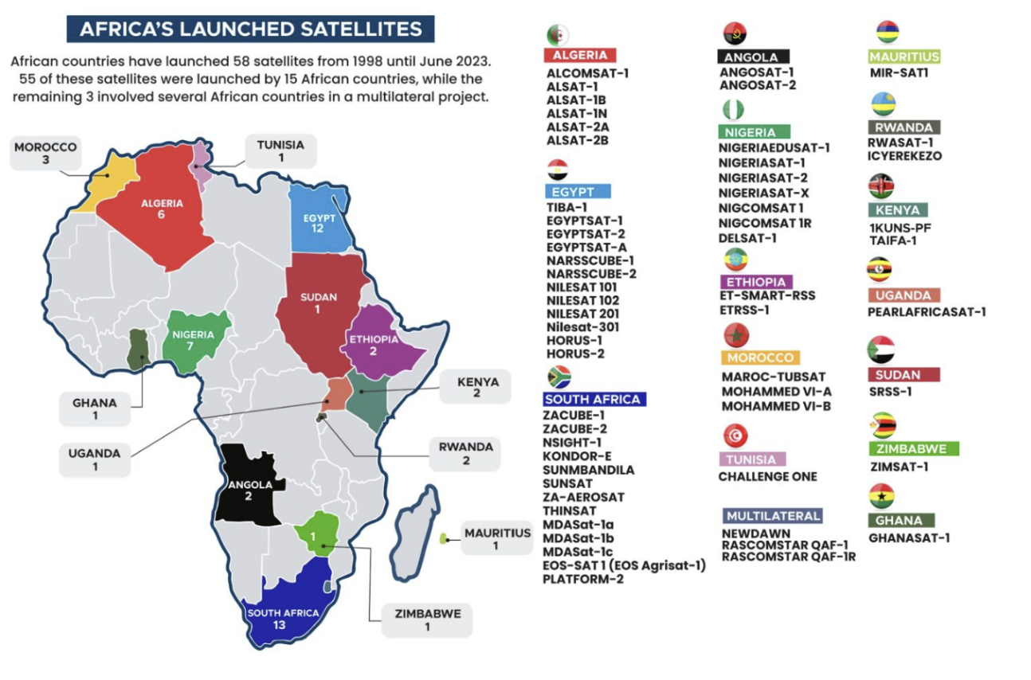

Low Earth Orbit (LEO) Satellite Providers
New LEO constellations are seen as a disruptive technology that may provide viable options to previously unconnected communities. They offer low latency and relatively high throughout in comparison with GEO satellites, and small, easy-to-setup user terminals.
Some of the LEO services are listed here for reference. LEO satellite systems can be deployed very quickly post disaster which means they have a role to play in emergency communications.
- Starlink is a LEO constellation primarily designed for broadband data services. With terminal costs as low as USD500, it is both low cost and offers a “plug and play” set up. If there is power and a clear view of the sky, the Starlink system can be operational in less than 10 minutes. Whilst Starlink is not licensed to operate in The Gambia, it does provide a rapid set up disaster capability that has been demonstrated with disasters in other parts of the world such as Tonga following the Hunga Tonga-Hunga Ha’apai volcanic eruption and tsunami and Vanuatu following twin cyclones in 2023 and more recently with the floods in Brazil and Hurricanes Helene and Milton in the USA.
- OneWeb is another LEO broadband data system in the first phases of operational establishment. Approximately 430 of a constellation of 650 LEO satellites have currently been deployed. The company’s website states that “pop-up” connectivity can be rapidly deployed at short notice to areas with no existing or functioning base stations. Services are becoming available across Africa through various Service Providers.
- Amazon Kuiper a LEO broadband data system that replicates the Starlink model, designed for commodity pricing and ease of set up. Testing is currently underway with limited services by end of 2024 and global services in 2025.
- Iridium, an L-band Low Earth Orbit (LEO) systems, primarily used for voice communications.
- Telesat a Canadian company planning a constellation of 298 LEOs and only around 30 ground stations globally. Their Lightspeed satellites will leverage intersatellite links which allow satellites to create data connections to each other, rather than individually connecting to points on the ground. Telesat’s target market is enterprise level rather than individual consumers. The service is expected to launch in 2023 .
- Omnispace a LEO satellite start-up which aims to deliver 5G services directly to consumer’s handsets. That is, a “direct to device capability” — rather than “expensive and bulky” ground terminals .

VSAT
Different private companies offer data transmission services and Internet access through VSAT (Very Small Aperture Terminal) technology. These service offers vary in speed ranges according to each provider, which mainly use the frequency bands C, Ku and Ka and offer coverage across the country. The Gambia has over ?? licensed VSAT terminals in the country.

Broadband Global Area Network (BGAN)
BGAN is robust, affordable, and highly portable service. It provides a viable technology where IP cellular networks don’t exist or are unreliable. There is insufficient information to determine the use, quantity and locality of BGANs in The Gambia.

Satellite Phones
Various government agencies and other organisations in The Gambia keep satellite phones as back up communication devices. However, there are inconsistent records on what devices are available and what government agencies have those devices.
The increasing development of the Direct to Device (D2D) capabilities of LEO satellites and the ability to make use of 3GPP standards and the latest smart phone technology, will see a change in the market for dedicated satellite phones.

Spectrum Management
One of the key areas of management for PURA is that of radio spectrum. This spectrum is utilised by various providers for various services, such as mobile telephony, television and radio broadcasting and for radio systems support first responders, taxis and other such services.
Spectrum bands associated with Public Protection and Disaster Relief (PPDR) have been going through a harmonisation process, facilitated by the ITU. The Southern Africa Development Community (SADC) and the Communications Regulators’ Association of South Africa (CRASA) have been instrumental in this activity and ensuring that there is alignment across the SADC countries, making the movement and use of infrastructure that utilise these frequencies easier between responding and recipient countries. The outcome has led to the development of a framework for this harmonisation.

Frequencies for Public Protection and Disaster Relief (PPDR) Region 1
Based on the Framework for Harmonisation of Spectrum for Public Protection and Disaster Relief (PPDR) in SADC, there are several frequencies that have been harmonised for PPDR working across the ITU Region 1 frequency allocation arrangements. CRASA have undertaken this harmonisation work and provide reports and recommendations to Regulators on this harmonisation work. CRASA provides important considerations for the use of these frequencies for PPDR applications as outlined in Table 5 below.
PURA has provided guidance on the PPDR spectrum identified within these harmonised band as part of The Gambia National Frequency Allocation Table (GNFAT). In general, the frequencies allocated under the NFAP are in line with those identified by CRASA in Table 6 below.
Table 6 - Frequency Bands Adopted for PPDR
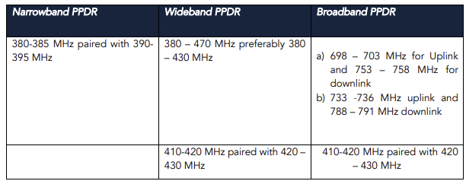
This is further articulated whereby PURA identify Emergency Frequency Allocations as per Table 7 below.
Table 7 – Emergency Frequency Allocation
Frequency | Allocation
TBA | TBA

Models for Use of Frequencies for PPDR
Many countries run national radio systems using the frequency ranges allocated for PPDR. There are many examples (Great Britain, Europe, USA, Australia and New Zealand) where national radio networks support the First Responder sector, enabling efficient communications between the various agencies concerned.
There are three models for PPDR using these frequencies
- Model one: Exclusively public safety-dedicated network, with spectrum being used exclusively by public safety users.
- Model two: Shared public safety and commercial network, with distinct public safety and commercial network cores, and priority access and pre-emption rights for public safety use during emergencies and other times of need.
- Model three: Commercial network, i.e., public safety users obtain services from one or multiple commercial providers.
The model to be used should be based on a specific study for the country in which it is being built, and should include an analysis of the compliance of the following general principles:
- Interoperability: Allow first responders on the network to access other users, as authorized, from anywhere and at any time.
- Permanent access: Allow first responders to have permanent, immediate, and uninterrupted access to the network.
- Coverage: Provide access in uncovered urban, rural and remote areas.
- Resilience: Be resilient and robust in meeting the access requirements mentioned above.
- Provide mission critical services: Offer mission critical services to first responders, including data and video.
- Security: Include network security mechanisms for information and data.
- Sustainability: Be friendly to the environment and establish resources to keep updated in the future, meeting the goals and needs required.
- Accessibility: Be accessible to the entire community of first responders.
- Spectrum use: Use spectrum efficiently and effectively.

Trunked Radio
Trunked radio is used in The Gambia by a variety of organisations, both government, private and first responder agencies. All these systems are licensed under the appropriate rules and regulations. It is possible that the models outlined above could be put in place and provide an improved service to some of those agencies and enterprises that are utilizing self-built and managed solutions, that may not be optimally designed.

Broadcast Services
Broadcast services in The Gambia consist of:
- One National broadcaster (TV and radio)
- Multiple (4) free to air and subscription television stations
- Numerous commercial (9) and community (38) radio broadcasters
A recent report by UNESCO indicates that for the marginalised population the mobile phone is a primary source of information.

Other Networks and Telecommunications Equipment
There may be miscellaneous networks or telecommunications equipment other than those described in this document. One such area for further investigation is the use of VSAT services in universities and resort locations for example. Another is to create and maintain a register of organisations who have satellite phones.

Humanitarian Networks
There are existing humanitarian telecommunications networks which include both radio and VSAT systems. All UN organisations or other major humanitarian agency have access to a single VHF and HF radio systems, whilst the VSAT systems are shared across all agencies.
Table 8 - Humanitarian Networks
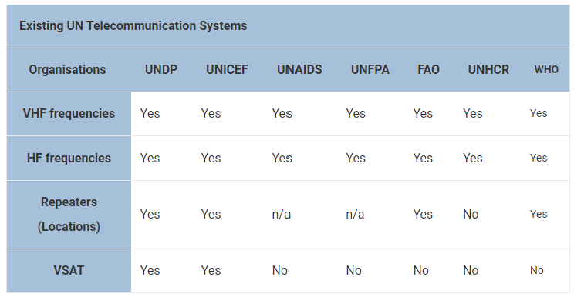

Radio Amateurs
Countries should encourage use of amateur radio as a redundant means of communication when all other network infrastructures fail.
With a low-power high-frequency (HF) transceiver, a car battery, and wire for an antenna, a skilled amateur can establish communication from virtually anywhere using his or her knowledge of ionospheric propagation. At the local level, organized groups of amateurs are prepared to assist their communities using personally owned VHF and UHF equipment.
The International Amateur Radio Union (IARU) provides an Emergency Communications Training Guide to help amateur radio societies train their members to participate in emergency events.
The Gambia does not appear to have active amateur radio operators. There is evidence of an amateur society known as the Radio Society of The Gambia (RSTG), however, this group appears to be inactive and would need further investigation into its operation. RSTG is the National Member Society representing The Gambia in the IARU.
Implementation Task 6:
An up-to-date repository of critical infrastructure is important in a disaster situation. Whilst this information does not have to be held by PURA, there must be confirmation that the information is available, regularly updated and can be accessed when required. Therefore, PURA should put in place a methodology to regularly review the network inventory and coverage of mobile and fixed telecom/ICT operators, and radio and television broadcasting.
All telecom/ICT service operators, mobile, fixed, and radio and television broadcasting operators, as well as government networks, in conjunction with the PURA, should develop (or update) and present for approval to the NDMO a vulnerability analysis of the critical infrastructure of their networks, including an inventory of the infrastructure, and power, maintenance and connectivity evaluations along with consideration of the risks associated with cyber security.
PURA should also, maintain an updated database with the focal points in charge of technical aspects as well as with those in charge of communication of alerts and relevant information regarding disasters. Include network information and coverage of radio amateurs and first responders (police, firefighters, etc.) and identify any gaps.
PURA should also consider the assessment of the implementation of other options on telecom/ICT infrastructure, such as including satellite devices for voice/broadband communications, academic networks and community WiFi to strengthen emergency response and recovery activities
Information should be confirmed on VSAT capability in the country, including those systems already in situ and systems in storage for use as required.
Coverage maps of all mobile network operators should be reviewed and updated accordingly. Coverage maps should be easily available to the public for information purposes and should be available at a detailed level on an as-required basis.
.

International Cooperation
Countries that are not signatory to the Tampere Convention should initiate the process to become part of it.
To be updated following stakeholder consultation
The Gambia is not a signatory to the Tampere Convention. However, the country is a signatory to, member of, or potential beneficiary of numerous regional and international treaties, conventions or agreements that have the purpose of reducing the effects of disasters, as well as preparing, responding to and recovering from emergency situations. Some of these are presented below.

Tampere Convention
The Tampere Convention on the Provision of Telecommunications Resources for Disaster Mitigation and Relief Operations calls on states to facilitate the provision of telecommunications assistance to mitigate the impact of a disaster.
The Tampere Convention calls for removal or lessening of organisational barriers that impede the flow of information between the various elements of the international network for disaster response. This includes, among other elements
- the establishment of immunity against the confiscation of equipment,
- the prompt issuance of the appropriate licenses (e.g. telecommunications licenses, use of spectrum, etc.),
- the development of mechanisms for the timely import and export of infrastructure that was used under the Convention, and
- the facilitation of approvals for the arrival and departure of the assistance personnel to their country of origin
The Gambia is not a signatory to the Tampere Convention and should initiate the necessary procedures to sign and ratify the treaty. While The Gambia already has some legislation and regulations in place, applying the contents of the Convention to current legislation, may require either adding or complementing the provisions of the current regulations regarding customs and excise and telecommunications for international assistance on DRM.
If The Gambia ratifies the Convention, it is important that PURA, MoCDE, Office of the Prime Minister, the Ministry of Foreign Affairs, as well as the customs authority, initiate the required steps for its implementation. Likewise, it would be relevant to make certain legislative and regulatory adjustments at the national level, thereby complementing the current regulations on international assistance for disaster management. These steps will help those involved in DRM in the country internalise and effectively adopt the legal framework.
In accordance with the above details, and within the framework of the Tampere Convention, the responsible authority regarding telecom/ICT regulation, PURA must establish specific regulations for the implementation of the Convention including for example:
- Exempt international aid provided through the Tampere Convention from any type of charge, including charges for the use of radio spectrum and for service licenses, among others.
- Temporarily and expeditiously issue authorization for any use of the radio spectrum that is necessary, in line with the provisions of national legislation.
- Simplify or create exemptions to any other existing regulation that prevents the use of telecom/ICT resources for international aid under the Tampere Convention.
To execute the agreement, in the event of ratification, it is also recommended that the government entities of the cooperation framework be informed, so that all stakeholders have clear knowledge of the relevant legal provisions and can effectively apply them when a disaster does strike.

Africa Risk Capacity Agreement
The Gambia signed a Memorandum of Understanding (MoU) with the African Risk Capacity (ARC) on January 23, 2016, to work together and better prepare to deal with extreme weather events and natural hazards efficiently. ARC was established in 2012 as a Specialised Agency of the African Union to help Member States improve their capacities to better plan, prepare, and respond to weather-related disasters; and particularly, to reduce the risk of loss and damage caused by extreme weather events’ affecting Africa’s populations. This task is accomplished by providing, through sovereign disaster risk insurance, targeted responses to natural hazards in a more timely, cost-effective, objective, and transparent manner.
Upon entering the MoU, the government of The Gambia agreed to commit to carrying out technical work required under the Capacity Building Programme for one year, as well as to avail themselves of relevant technical experts who form a core government team and act as focal points within their department for specific work streams of the programme, and also allow these staff members to retain their office space and dedicate the necessary time to ARC activities.
In the same manner, ARC agrees to provide resources (e.g., Africa RiskView software) that will enable the government team to complete the activities of the programme; provide training inside and outside the country for the government team on various aspects of the programme, thereby transferring knowledge and capacity; and provide technical expertise and guidance throughout the programme.

Crisis Connectivity Charter (CCC)
Satellite-based telecommunications are an extremely useful and quick-to-deploy solution when land-based networks are damaged by natural disasters.
Under the Crisis Connectivity Charter, the EMEA Satellite Operator’s Association (ESOA), the Global VSAT Forum (GVF), the UN Office for the Coordination of Humanitarian Affairs (OCHA) and the Emergency Telecommunications Cluster (ETC), led by the World Food Programme (WFP),​ have defined and committed to a framework to improve the existing satellite-based response and enhance connectivity at times of crisis.
This industry-led mechanism is activated by the ETC. It enhances coordination between all actors in the satellite industry to enable the swift prioritisation of critical, humanitarian traffic, when requested.

International Charter on Space and Major Disasters
This charter promotes collaboration among space agencies around the world to make satellite data available to the DRM authority in an affected country during an emergency. The Charter combines Earth observation assets from 17 different agencies, including high-resolution satellite images from commercial operators.
The Gambia is a member of this charter and can submit requests to activate the Charter for satellite data on relating to a disaster.

United Nations Disaster Assessment and Coordination (UNDAC)
The UNDAC team was established in 1993 and today consists of more than 250 national emergency managers from more than 70 member and participating countries, together with staff from OCHA and 16 international and regional organizations including UN agencies.
The UNDAC system counts on the participation of the following organisations:
ECHO & Civil Protection Mechanism, CEPREDENAC, ASEAN, ECOWAS, IFRC, ISDR, OCHA, UNDP, UN-DSS, UNEP, UNICEF, UNOSAT, WFP, World Bank, WHO & PAHO.
UNDAC teams consist of experienced emergency managers and technical support personnel and can be deployed in 12-48 hours of a request. They are a neutral, international asset provided free of cost.
Technical partnerships of the UNDAC system include NGOs such as MapAction and Telecoms sans Frontières (TSF), offering services such as emergency mapping and emergency telecommunications when deployed with an UNDAC team. UNOSAT is another operational partner who provides satellite imagery and GIS support to the humanitarian community.

United Nations (UN) Agencies
The Gambia became a full member of the UN in 1965. The UN has 23 agencies implementing programs: FAO, ILO, IOM, UNDP, UNCDF, UN Environment, UNESCAP, UNESCO, UNFPA, UNICEF, UNISDR, UNOCHA, UN Women, WFP, WHO and WMO.
UNDRR (previously the UN International Strategy for Disaster Reduction, UNISDR), has been advocating for disaster risk prevention and preparedness for the last two decades.
The International Telecommunication Union (ITU) is the United Nations specialized agency for information and communication technologies – ICTs.
The ITU undertakes various activities related to issues of telecommunications during emergencies including provision of:
- manuals on emergency telecommunications
- emergency radiocommunications specifications applicable to all phases of a disaster
- databases of available frequencies for emergency radiocommunication services on land and space
- the International Emergency Preferences Scheme and a Common Alert Protocol.
The World Meteorological Organization (WMO) is an intergovernmental organization with a membership of 193 Member States and Territories WMO is the specialised agency of the United Nations for meteorology (weather and climate), operational hydrology and related geophysical sciences a year later. WMO regional offices coordinate technical and institutional support to the National Meteorological and Hydrological Services at the regional level.
See also 5.8 World Food Program (WFP) – Emergency Telecommunications Cluster (ETC)
Implementation Task 7:
As a non-signatory to the Tampere Convention, the relevant government agencies or entities in The Gambia, including the customs authority, should review existing regulations to simplify or create exemptions to any regulation that prevents the use of telecom/ICT resources for international aid to allow for The Gambia to become a signatory and ensure effective implementation of the Convention
Continue to maintain contacts in and work in co-operation with different international agencies, such as the International Telecommunications Union (ITU), the ETC (Emergency Telecommunications Cluster), other international bodies and with regional partners on issues related to preparedness and response to disasters or emergencies.

Preparedness Phase

Early Warning and Alert Systems
Each Member State should assess, develop and/or enhance existing emergency alert and EWS, including surveillance and monitoring systems for probable threats prior to the occurrence of disasters and/or emergencies and solutions for warning and alerting the public through using different means of communications.
To be updated following stakeholder consultation
Establishing and improving early warning systems is identified as a top priority issue under the UN EW4All initiative. The importance of early warning information to reduce disaster risks by allowing stakeholders to make early decisions and take early action is well recognised and therefore clarification and implementation of an Early Warning System (EWS) is a priority NETP implementation task.
Developing and implementing any EWS will rely on key technical experts and organisations responsible for scientific data collection and knowledge. Such organisations include:
- the Meteorological Services
- the Hydrology Department
- the Geotechnical Agencies; as well as
- Electronic sources such as those provided by United Nations Operational Satellite Applications (UNOSAT) and other international and regional information sources among others.
This identifies the EWS capabilities as being:
- the interpretation of disaster risk information
- hazard and risk mapping
- tracking, monitoring and forecasting impending events
- processing and disseminating understandable warnings to political authorities and the population; and
- taking appropriate and timely actions in response to warnings.

Early Warning System Architecture
There are three key components of an early warning system that must be considered to ensure the effective input, message and delivery. These inputs are
- Monitoring Systems
- Message Creation System
- Alerting or Distribution System
Whilst an early warning system can be implemented without a holistic system, integrating these three components, its effectiveness and efficiency is limited. It is only when all three components are integrated together that a true Early Warning System 4 All is implemented.
Figure 22 below provides a top-level view of an EWS architecture that considers the three components, in this case; live feeds are monitoring, control room and alert aggregator are the message system and communication channels are the alerting distribution system.
Now, if an EWS exists and is operational it is standalone and is not aggregated into a larger system. The objective is to audit, consolidate and aggregate any EWS system in place into a single solution for The Gambia.
Figure 18 - EWS Top Level Architecture
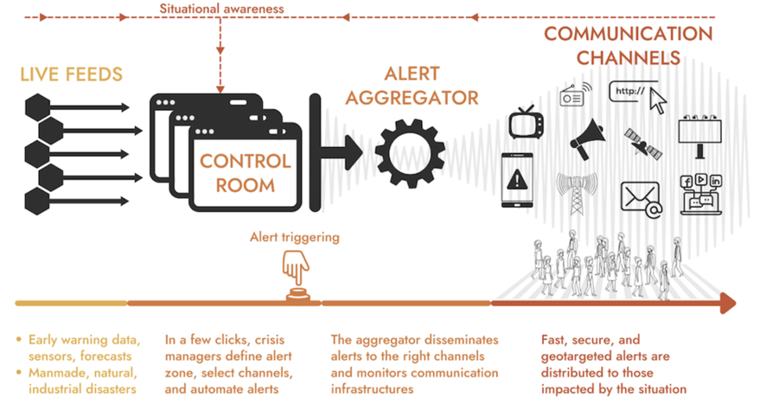

Monitoring Systems
The first building block of an EWS is a monitoring system. These systems are designed to monitor certain types of hazards that may impact a location. Consequently, the need to have accurate vulnerability maps helps in determining locations for these monitoring systems. There are many types of monitoring systems, but those that are likely to be implemented in The Gambia are as outlined below.

Flood/Drought Monitoring
Flooding has been seen as a frequent disaster that strikes The Gambia. Therefore, a consolidated flood monitoring system is required to provide data for the appropriate Agency to decide on the likelihood of a flood event. This output decision feeds into the message to be disseminated.
The Gambia does not appear to have a consolidated flood monitoring system implemented but does have access to the African Flood and Drought Monitor as shown in Figure 23 below, which was originally developed by Princeton Climate Institute (PCI) in collaboration with the University of Southampton and Princeton University. The system is based on a set of ground, satellite and modelled datasets, which are combined to provide a consistent picture of hydrological conditions close to real-time, as well as forecasts out to 7-days for floods and out to 6 months for drought.
There are other examples of Flood monitoring Systems such as a Community Flood Monitoring system known as Community Water Watch (CWW) implemented by the Tanzanian Red Cross in Dar Es Salaam. CWW utilises FloodTags through the monitoring of social and online media combined with hydrometeorological data and analysed via Artificial Intelligence, the systems can alert stakeholders of potential flood impacts, allowing the community to act. This standalone solution is only one example of likely numerous standalone monitoring and early warning systems that are likely to be in place.
Figure 19 – African Flood and Drought Monitor
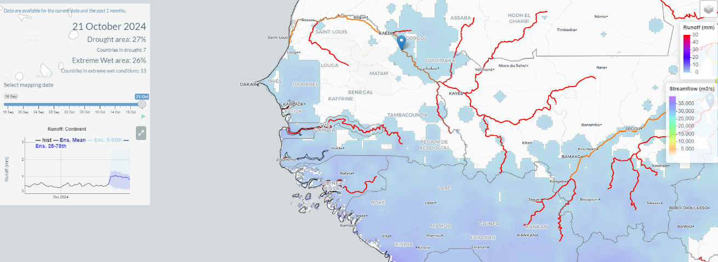

Automated Weather Station Network
The Gambia has several Automated Weather Stations (AMS) across the country. These AWS are currently managed by the Meteorology Division of the Ministry of Fisheries and Water Resources, however, there appears to be no publicly available viewer nor any information on how the output warnings are disseminated to the public. An opportunity exists to integrate these AWS systems into the service that is provided by the Southern Africa Science Service Centre for Climate Change and Adaptive land Management (SASSCAL) to allow public viewing of the data records. This would create a significant monitoring system for weather events, which should be considered as an input into the EWS solution.

Message Creation
The output of the monitoring systems needs to be analysed and acted upon. Analysis can either be done by a human operator, or as is becoming more common with the use of Artificial Intelligence. Once a decision has been made the message must be compiled so that it can be understood by the population. This is facilitated using the Common Alerting Protocol (CAP).
The Department of Fisheries and Water resources is the only registered alerting authority for The Gambia on the WMO’s website. According to the data The Gambia has an active implementation of CAP, however this appears to be last used in 2022.

Common Alert Protocol (CAP)
The adoption of Common Alert Protocol (CAP) is an important step for better disaster management. Information shared at the right time, in an understandable format, by trusted sources, can be the most effective life-saving tool in the event of an emergency. Early warning systems have improved over the years, but people continue to perish and suffer from hazard threats because, too often, early warning messages arrive too late, are not understandable enough, or do not provide clear guidance.
To overcome those challenges the ITU the IFRC and the WMO have endorsed the "Call to Action on Emergency Alerting", which states that by “2025 all countries have the capability for effective, authoritative emergency alerting that leverages the Common Alerting Protocol".
CAP is a simple but general format that enables authorities to deliver early warnings and alerts to all people and communities at risk, via all kinds of ICT networks. Disseminating a consistent warning message simultaneously over many different​ warning systems, increases the warning effectiveness while simplifying the task of sending the messages.
Technologies to be used (if available) include:
- Mobile and landline telephones,
- Internet (e-mail, Google, Facebook, Twitter, WhatsApp, smartphone apps, online advertising, Internet of Things (IoT) ​devices​​​, in-home smart speakers, etc.),
- Sirens (in-building or outdoor),
- Broadcast radio and television,
- Cable television,
- Emergency radio,
- Amateur radio,
- Satellite direct broadcast, and
- Digital signage networks (highway signs, billboards, automobile and rail traffic control), among others.
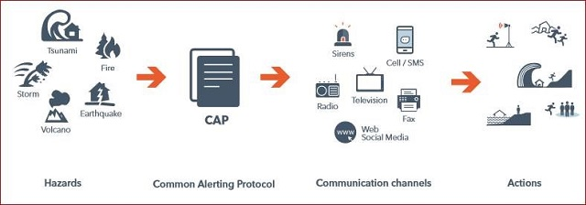
Figure 20 - Common Alerting Protocol (CAP)

As an example of CAP alerting, the Tanzania Meteorological Agency is an active user of CAP providing bulletins via CAP as shown in Figure 25 below. With the ability to send CAP messages a national and centralised alert aggregator should be established to receive all types of warnings and transpose these warnings into CAP alerts and then send the alerts to different alerting disseminators.
Figure 21 - Example CAP Message
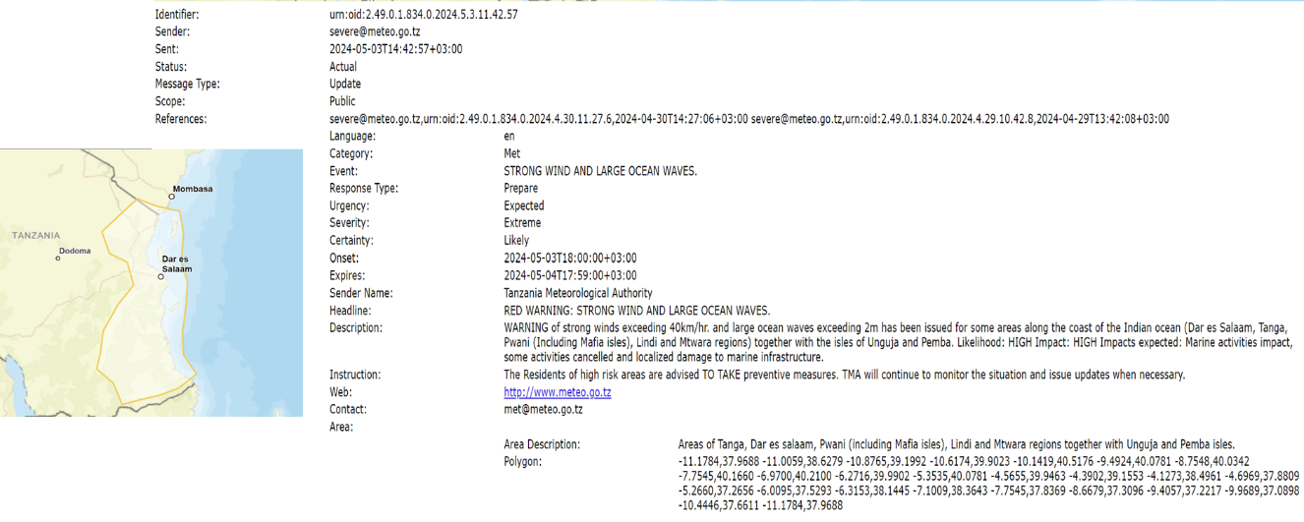
In addition, CAP offers capabilities including, but not limited to:
- Flexible geographic targeting using latitude/longitude shapes and other three-dimensional geospatial representations
- Multilingual and multi-audience messages
- Improved message update and cancellation functions
- Template support to frame complete and effective warning messages
- Digital encryption support and signature capabilities
Sahana Software Foundation offers SAMBRO, a messaging broker designed to publish and subscribe CAP warnings that does not have any licensing fees. The Sahana Foundation has been doing research and development of cultural context, national and regional pictograph dictionaries that can be used by alerting authorities to make warning messages more inclusive and accessible.

Alert Dissemination
Without the ability to disseminate alerts to the population, the effectiveness of an EWS is limited. Today (2022), three out of four people around the world own a mobile phone. Global active mobile subscriptions reached 87% of the population, and network coverage is available for 95% of the world, at least with a 3G network. The Gambia alone has over 113% of the population having a mobile phone. This makes mobile networks an incredibly powerful communication channel to alert populations about an imminent hazard.
Two different technologies, Cell Broadcast (CB) and Location-Based SMS (LB-SMS), have proven to be very effective in alerting about imminent hazards, and are already in use in several countries.
Location-Based SMS uses subscribers’ mobile numbers for point-to-point communication, to send a message to all mobile phones detected in a risk zone. While Cell Broadcast uses a different network than SMS (the mobile signalling channel for point-to-area), enabling messages to be sent almost immediately to millions of people without network congestion. In that sense, by using cell broadcast (CB) and/or location-based SMS, warnings can be targeted to reach only those located in an affected area. Additionally, the alerts can be adapted to specific requirements, such as a user’s language.

Location-Based SMS
Location-Based SMS (LB_SMS) combines traditional SMS with cell-based location. That is, uses the existing SMS channel and combines it with the accuracy of cell-based location to send the messages. This allows governments, public agencies and mobile operators to send SMS notifications and warnings to a list of mobile subscribers located in a specific geographical area of interest. In general, an LB-SMS message is simply a regular SMS message, only sent to a subset of the mobile network’s attached devices which happen to be in a particular geographical area.
This technology, given its characteristics, has advantages that others may not have, and enables options that could be useful to alert the population in certain situations or when facing specific threats. Some of the advantages of LB-SMS technology are:
- Confirmation of Delivery (bi directionality): Unlike cell broadcast technology, LB SMS provides confirmation of delivery and “service performance” data in real-time, as it is a two-way communication tool. This allows operators and authorities to store messages, showing a count of recipients, individual delivery reports, language specific content (based on recipients’ country code), send updates, and receive feedback or replies by the users, which may provide vital information to emergency services, facilitate the monitoring of situations, and better plan the deployment of resources. It may also be useful for demographic groups such as people with special needs, elderly, children, etc. to request assistance during evacuations.
- Provides follow-up messaging (granularity): Allows customized messaging for vulnerable groups, and to send individual messages to certain numbers even if people have left the affected area. This can be particularly useful in certain situations, such as pandemics, where, for instance, a follow-up medical treatment is needed, or for hazards such as chemical attacks.
- Service Barring and Familiarity: Users cannot by default opt out of LB-SMS, as their only way to do it is by turning off their device, setting it to silent or ignoring the alert. Also, unlike other technologies, SMS are a universally known communication channel, which may facilitate alerting specific demographic groups such as people with special needs or the elderly. Traditional messaging may also provide lesser chances of causing panic while sending alerts for incidents that can be predicted a few days in advance. This characteristic, nonetheless, may be seen as a disadvantage, as traditional messages can be easier to disregard: these messages look like any other messages sent to a phone.
Although these advantages allow an efficient use of this technology in certain situations, LB SMS also presents some disadvantages and limitations, such as the following:
- The use of classical SMS requires having a number database: This technology is ideal as a personal one-to-one messaging solution but requires the establishment and maintenance of a database of target numbers for bulk messaging. In other words, for all areas that the Mobile Network Operator (MNO) must deliver messages into, a list of all users currently located in those areas must be always kept up to date. This is usually not the case at the granularity of the single cell level, as knowledge of subscribers’ locations is not required for normal operation. Also, this may limit dissemination of information for persons at risk without subscriptions to specific MNOs (e.g. tourists).
- Network congestion: Even though the capacity of the networks has been largely increased in recent years, this technology requires the use of networks that are often severely congested during emergency situations, causing delays in message delivery.
- Security: Unlike other technologies, where messages can only be sent by authorized personnel who have been given access to the system, in LB-SMS, messages can be sent from any source and the identity of the sender is difficult to verify
- User interface: This technology cannot over-ride the mute function and it doesn’t necessarily make the phone vibrate.

Cell Broadcast
Increasingly, countries around the world are adopting CB for public warning systems. In many countries, CB builds on a CAP system.
CB is a broadcast technology operating at the default granularity of a single cell up to any number of cells in a particular region. It is a point-to-multipoint service that allows to send a text message to a specific area; local, regional or nationwide, to a large number of subscribers, including visitors from other countries and users that arrive to the affected area. As there is no need to know the number of the subscriber’s mobile device to send the message, there are no privacy concerns with CB. This type of broadcast can also be repeated during a configurable period, or the message could expire after a single broadcast.
When a CB message is received by the user, it is displayed automatically on the mobile phone screen with a special ringtone and vibration, disabling its use until the user acknowledges the alert. CB also allows text-to-speech in certain cases, and the users´ desired language.
As in the case of LB-SMS, this technology also has some advantages and limitations compared to other options. Some of the main advantages of CB are:
- Message Display: Messages can be broadcast in any language and displayed depending on the mobile device’s language settings. Also, the message is displayed with no need of user interaction, and it has a distinct warning tone and vibration pattern.
- Message Delivery: As CB works on a one-to-many basis, one message can be sent to millions of devices almost immediately. Also, because a CB message is sent only once to each cell, and from each cell it is broadcast repeatedly to all attached mobile devices, the network load for a given warning message is very low. In addition, CB traffic is either carried with the highest priority (3G/4G) or on a dedicated channel (2G). This means that this technology will always work, even when the network is congested.
- Geo-Fencing: Since 2019, CB has been enhanced to allow for geo-targeting, that is, using the mobile device´s geolocation capability to improve accuracy to levels equal to those of satellite navigation. Using the network target area geometries (polygons and or circles), the geo-fencing feature can use satellite navigation and the cell information to establish the mobile devices location with an accuracy level of meters. Indeed, geo-fencing can facilitate alert originators to issue warning messages to, for instance, those living on the left side of the highway but not on the right.
- Security: In CB, the recipients remain anonymous as this technology does not require registration of numbers or maintenance of a number database.
On the contrary, CB has 2 main limitations compared to technologies like LB-SMS: first, CB does not have the capability to provide confirmation of delivery in real time; and second, it does not provide “follow-up” capabilities (less granularity), and it can only be used for 1-way communication. Other disadvantages that this technology had, have been recently overcome. For example, since 2012, every device can support Cell Broadcast. Also, currently there is no need no sign up or opt-in to receive CB messages (although the user can still turn off CB reception), and no manual configuration is required by the end user as the technology is now included by default in every handset.

Table 9 - Summary of CB/LB-SMS characteristics
Characteristic | LB-SMS | CB
Transmission type | Point-to-point | Point-to-area
Mobile number dependency | Requires database of phone numbers | Does not require database of phone numbers
Bi directionality | Yes. Users can respond directly to sender | No. Message should contain a URL or number to reply
Granularity | Allows follow-up messaging and customized messages for specific numbers | No follow-up or customized messaging.
Congestion | Subject to network congestion | Always available
Security | Source of message cannot be verified | Only mobile operator or authorities can broadcast messages
Service barring | No barring | Users can turn off CB reception
Delivery Confirmation | Yes | Not available
Repetition rate | No | Message can be repeated between 2 sec. and 32 min.
Language Selection | Only based on recipients’ country code | Yes

In general, any of the technologies described, CB and LB-SMS, can be very useful when it comes to disseminating early warnings or relevant information during a disaster response. Cell Broadcast allows sending instantly loud distinctive alerts to a very wide population without congesting the network, while Location-Based SMS makes it possible to send traditional alert messages point-to-point in each area. It is highly recommended to deploy both technologies in a complementary manner.
With both technologies, DRM authorities can use CB for larger-scale emergencies, for instance, that require rapid alerting to a large population, or for events that are more likely to congest the mobile network, such as earthquakes, tsunamis, or hurricanes. While LB-SMS can be used for prolonged emergencies that require regular updates, for example, such as heat waves or pandemics. To sum up, Table 14 above compares the main characteristics and capabilities of both technologies, LB-SMS, and CB.
Implementation Task 8:
NDMA, MoCDE and PURA should conduct an audit of early warning monitoring solutions and systems that are currently in place in The Gambia. This will provide the necessary input information for an aggregator solution for the early warning system.
The Gambia must continue to develop surveillance and monitoring systems for probable threats prior to the occurrence of disasters and/or emergencies however these should be integrated into any early warning system that is to be developed.
Utilising this information NDMA and MoCDE should move to develop and improve an early warning and alerting systems strategy including the implementation/development of a centralised alert aggregator to take advantage of the Common Alert Protocol (CAP) implementation and to help with consistent, authoritative, impact-based forecast and alert messaging. The appropriate staff should undertake WMO’s online CAP training, a CREWS workshop if not already undertaken or an ITU CAP Implementation Workshop.
The current Common Alerting Protocol (CAP) Alerting implementation should be examined to assess its efficacy and identify opportunities for expanding its reach to as broad several different channels as possible. Any dependencies for downloading applications to mobile devices should be assessed for limitations in scope and coverage.
PURA should work with the carriers to develop/implement a Cell Broadcast capability to send alerts via the mobile network infrastructure. Ideally this will build on the CAP implementation.
PURA should work with broadcasters to develop/implement the capability to send alerts via the broadcast radio and TV network infrastructure. Ideally this will build on the CAP implementation
The role of amateur radio should also be reviewed to establish opportunities for further refinement.

Training and Drills
Telecommunications trainings and drills for emergencies should be regularly carried out to improve emergency responders’ capacity with communications equipment as well as to enhance their ability to execute policies, plans, and procedures governing the use of communications networks.
To be updated following stakeholder consultation
The development of an effective NETP should also include practical strategies that improve the capacities and training of all people involved in the management of emergency telecom/ICT. The development of these capabilities improves the speed, quality and effectiveness of emergency preparedness and response. Effective training and exercise programs can reinforce the competence of emergency services with telecommunications equipment, as well as improve their ability to execute the policies, plans and procedures that govern the use of telecommunications throughout the process of disaster risk management.
It is important that these trainings and drills occur in all the areas identified throughout the planning process (including institutional capacity, management of telecom/ICT networks, among others), and that they involve all actors, from administrators that lead the emergency responses, to the general community that uses telecom/ICT. There are several areas that simulations can be beneficial, such as but not limited to,
- Testing national and local strategies, protocols and frameworks on the use of ICT for disaster response
- Identify gaps and challenges
- Test the roles and responsibilities of various stakeholders
The Emergency Telecommunications Table-top Simulation Guide , developed by the ITU, as well as the online training tool on How to Develop Tabletop Simulation Exercises (TTX), provide all the relevant information needed to develop and carry out this type of exercise.
The WMO offers an online CAP basics course.
Implementation Task 9:
Training and drills should occur in all the areas identified throughout the planning process, including institutional capacity and management of telecom/ICT networks. Telecom/ICT training and drills for emergencies should be regularly carried out to improve emergency responders’ capacity with telecom/ICT equipment, as well as to enhance their ability to execute policies, plans and procedures governing the use of telecommunications networks.
Table-top exercises (TTX), or discussions of a simulated emergency in a low-stress environment, should conducted, to test the NETP and other procedures for improvement.
The telecom/ICT sector, as well as any other relevant actors involved in telecom/ICT management including enablers for ICT (such as power and transport agencies for example), should actively participate in these drills and exercises, and develop and carry out their own, to effectively implement the NETP. These sector-specific exercises and drills should be coordinated with those developed by other relevant stakeholders to avoid duplication of efforts. The ICT simulation exercise can be conducted at national (strategic level) and sub-national (tactical level).

Support for People with Specific Needs
Authorities working together with network operators and telecom/ICT service providers, should develop mechanisms to understand the accessibility requirements needed to guarantee that vital digital communication technologies are inclusive and, therefore, are accessible to all persons.
To be updated following stakeholder consultation
Telecom/ICTs can also be a key tool in disaster response and management operations to reach traditionally marginalized or especially vulnerable groups before, during and after a disaster.
The development of multi-hazard early warning systems (MHEWS) must be inclusive of communities most at risk with adequate capacity to act on early warnings, and ensure better availability, quality, and sharing of data, financial resources, and effective governance and coordination arrangements to fully implement the call by the UN Secretary-General to ensure every person on Earth is protected by early warning systems (EWS) by 2027.
Telecom/ICTs can use multiple modes and channels, such as TV, radio, SMS-text messages, or the different Internet-based services and resources: video, instant messaging over the Internet, web conferencing, and social media, among others, that allow instant communication and sharing of photos and/or videos and satellite communications.
Therefore, dissemination of disaster preparedness and planning content should be undertaken through different formats. For example, subtitles can be included in visual communications so that persons with auditive difficulties could receive the message; or visual and sound alerts could be introduced in public spaces to consider other possible needs that people might have.
Different telecommunication means available, such as radio or television broadcasting, text messages and/or audio messages through mobile providers, social networks, and applications such as the Sahana Alerting and Messaging Broker, SAMBro, among others, should be used for this purpose.
Implementation Task 10
The Gambia’s authorities, working together with network operators and telecom/ICT service providers, should develop mechanisms to guarantee that vital telecommunication technologies are inclusive and therefore accessible to all persons, including people with disabilities, the elderly, women and girls, as well as refugees and immigrants. This should be linked to the early warning systems.

Where possible, working in collaboration with network providers, these messages should be via geo-location capabilities to those at risk.

All warning messages should be issued in the most appropriate languages and sign language and/or captions and infographics should be used where appropriate for the medium.

Contingency Plans
Public and private satellite and terrestrial networks, including mobile, fixed, and broadcasting operators must each keep their contingency and business continuity plans for emergencies updated.
To be updated following stakeholder consultation
A contingency plan for telecom/ICT must include specific procedures depending on the unique characteristics of that location, such as the level of connectivity of the site, the facilities or deployable equipment available in the area, and redundancy, among other elements.
This contingency planning, in addition, should include solutions that can be carried out by the agents responsible for disaster risk management to maintain the operation of the service in the affected area. This will be helpful in making advance decisions on resource management, and in developing procedures for the expected use of the full range of available technical and logistical responses, especially with respect to telecommunications.
Telecommunications operators in The Gambia should have updated contingency plans for responding in case of emergencies and disasters. These contingency plans focus on key aspects, such as critical infrastructure and always maintaining the continuity of the service. A mechanism needs to be in place to ensure that operators regularly provide these contingency plans to PURA for review.
Implementation Task 11:
Telecom/ICT network and service providers must develop contingency plans for emergencies in line with any updated national plans, and in conjunction with the authorities responsible for telecom/ICTs and for disaster risk management. Measures such as network redundancy, secondary energy sources, and developing solutions for international cable cuts, among others, must be considered and included in the network design, especially in those areas at risk according to the hazard maps, and considering the network vulnerability analysis.

Standard Operating Procedures (SOP)
Develop, update and strengthen SOPs for emergency and disaster response related to communications within and among agencies and technical means for communication (voice/data), including interoperability.

To be updated following stakeholder consultation
Standard Operating Procedures (SOPs) are defined as formal written guidelines or instructions for incident response. They generally have both operational and technical components and allow emergency response personnel to act in a coordinated manner across all disciplines in the event of an emergency. These detailed instructions or procedures promote a uniform and standardized response during emergency response operations. These SOPs should be aligned with the legislative and regulatory frameworks as well as with the specific policies and plans related to DRM.
The Gambia does not have in place a set of Standard Operating Procedures (SOP’s) relating to DRM activities
A SOP standardises the use of emergency telecommunications terminology and enables deployment of backup solutions and/or redundant infrastructure and services.
Further all Government agencies and telecommunications service providers should be obliged to create and maintain Standard Operating Procedures which include a plan for continuation of telecommunications of the organisation in an emergency or disaster event.
SAFECOM, the emergency communications advisory group of the United States Department of Homeland Security, defines SOPS as “formal written guidelines or instructions for incident response, which generally have both operational and technical components, and allow emergency response personnel to act in a coordinated manner across all disciplines in the event of an emergency”.
SAFECOM has developed a guide to help communities write clear and effective SOPs, which are critical for preparing and responding to an emergency.
Implementation Task 12:
NDMA/PURA/MoCDE in conjunction with the participants in the Telecommunications Emergency Cluster should:
- Develop a set of Standard Operating Procedures for emergency and disaster response related to communications within and between agencies and network operators including the technical means for communication (voice/data), and interoperability. This should include an exhaustive list of all actions that may be required for disaster response.
- Define the government entities and the contact points (key decision makers) within these entities that must maintain communication during a disaster or emergency.
- Maintain an updated database with these focal points of every agency, and where appropriate any associated partner organisations, countries, or other external entities, involved in disaster management.
- Analyse the possible interoperability between the equipment (wireless) and the communication networks of the government entities.
- Establish a set of radio frequencies that can be used for the communications of the contact points (key decision makers) compatible with the radiocommunication equipment being used and ensure it is aligned for regional compatibility.
- Establish alternative methods of communications, if necessary, for example through existing communication operators.
- Develop connectivity plans for the satellite equipment available, if that is the case, to be used during a response phase as well as procedures for their use as primary or alternative communications between relevant stakeholders involved in disaster response.

Response Phase

Emergency Operations Centre - Communication and Coordination
Consider planning for the development of Emergency Operations Centres (EOCs) or communication and coordination command posts to provide critical communications to users in each organisation involved during the response phase of a disaster.
To be updated following stakeholder consultation
In the response phase, all contingency plans and standard operating procedures developed in the mitigation and preparedness phases must be executed. Telecom/ICTs must be determined to enable communications between first responders, decision makers in the government and the community.
During the disaster response phase, authorities can establish Emergency Operations Centres (EOC), communication or coordination command posts to provide critical telecommunications facilities to coordinate response efforts among all the different actors involved in disaster response. These include communications between response agencies, as well as between affected population and their families, and communications in shelters. Command posts can be fixed or mobile, local or remote, or be in a vehicle or in a shelter, among other possibilities.
The functions of these command positions are to assess the emergency, inform a dispatcher, and identify and request appropriate resources when necessary. Therefore, these command posts should be constantly in contact with the EOC and with each other (one in a remote location outside the perimeter of potential danger, and the other one on the site of the emergency, for example), in order to respond to the direct requirements that are generated in the emergency area, to dispatch equipment and personnel, to anticipate the need to provide more support and assistance, and to position additional resources in the area.
Considering this, it is important to maintain interoperable and continuous communications between command posts and between the rest of stakeholders involved in the response phase. With this purpose, the national government should use all available means of communication and technologies and maintain close coordination with the various agencies involved.
In the case of The Gambia, there is a Public Health Emergency Operation Centre (PHEOC) that has been implemented to support the response and management of health-related disasters such as the recent COVID-19 pandemic. It is unknown if the PHEOC will support and facilitate early warning and multi-hazard monitoring as well a central point of command and control and information gathering, analysis and dissemination for all types of disaster events.
Implementation Item13:
Consider planning for the support of the emergency operations centres or communication and coordination command posts to ensure that critical communications to stakeholders, first responders and the community is reliable.
Consider the telecommunication aspects of positions that may be fixed in a different location, mobile, local, or remote, and in a vehicle or in a shelter, among other possibilities. Maintaining interoperable and continuous communications between command posts and the rest of the stakeholders, Shelters and other key locations, is vital for an effective response to the emergency. The network connectivity to Shelters needs to be checked to ensure it is reliable, stable, and able to cope with expected demands.
Develop Standard Operating Procedures (SOPs) for all Emergency Operations Centres (EOCs) that include the coordination and communication procedures and roles for every stakeholder involved in the process, such as public and private persons and agencies, and international humanitarian actors, among others. These emergency operations centres should also have defined locations and determined equipment and telecom/ICT infrastructure requirements.

Collection and Analysis of Information
An in-depth review of current practices and future options for information collection, storage and management is beyond the scope of this first draft of the NETP.
A key element during the response phase of disaster management is to assess the impact on the telecom/ICT networks and prioritize the deployment of critical telecom/ICT infrastructure to the most affected areas. Gathering, evaluating and communicating information in a timely manner to the corresponding authorities (e.g. health entities, firefighters, police, among others), allows them to respond to the needs of the affected population as soon as possible.
Telecom/ICT networks should also be used to collect and analyse information related to the immediate needs of the population affected by the emergency, and to coordinate the safe delivery of such needs.
For achieving this goal, it is necessary to use all the available telecom/ICT networks and include collection of geospatial information from the disaster so as to analyse the information obtained and coordinate the response planning geographically.

Contact Centre for Emergency Awareness and Updates
Plan for the establishment of call centres during the response phase. These should be established to warn the affected population of new risks, disseminate updates about the emergency, and connect affected populations with their relatives.
To be updated following stakeholder consultation
During the response phase, it is also necessary to continue monitoring hazards to warn population of possible new risks, as well as to develop continued updates on the emergency.
To achieve this goal, multiple methods of communication such as sound and television broadcasting, text messages and/or audio messages through mobile operators, social networks, applications, among others, should be employed.
Call centres should also be established to connect affected populations with their relatives during the response phase. Generally, these call centres can be in shelters and should use means of communication that do not congest the networks, for example, text messages. These call centres can also be established in collaboration with telecom/ICT operators in additional locations such as hostels and hotels.
If the country does not have the capacity (e.g., equipment, human or financial resources) to establish this type of call centres, this service can be provided by international organisations, such as the UN through one of its branches. In the Central African Republic, for example, the Emergency Telecommunications Cluster established a dedicated Covid-19 call centre in the country’s capital, Bangui, to give advice to callers and to refer potential cases of Covid-19 to the Ministry of Health as part of the national response to the pandemic.
Implementation Task 14:
Investigate how call centres, potentially located in the EOC or shelters, can be established during the response phase to warn the affected population of new risks, to disseminate updates about the emergency, and to connect affected populations with their relatives, using means of communication that do not congest the networks (cell broadcast, CAP, infographics, text messages, geo-located information dissemination).
To establish these call centres, The Gambia could seek collaboration with telecom/ICT operators or international organisations to establish the required building and telecom/ICT infrastructure.
Recovery Phase

Assessment of Damage, Reconstruction, and Improvement of Infrastructure
Restoration and reconstruction of the telecom/ICT infrastructure should be based on lessons learned and the principle of building back better.
To be updated following stakeholder consultation
After a natural disaster occurs, initially it is necessary to maintain the availability of a minimum level of communications for those who carry out the damage assessment and reconstruction activity and to establish communication priorities to manage available telecommunications resources.
During the recovery phase, the damage caused to the telecom/ICT networks should be evaluated as a precursor to timely reconstruction and improvement of the damaged infrastructure. This reconstruction should seek, at a minimum, to restore telecommunications facilities to the same conditions as they were before the disaster. But, preferably, telecom/ICT infrastructure should be rebuilt on the principle of building back better, that is, reconstructing a more resilient infrastructure that can withstand future disasters.
Assessment, reconstruction, and improvement of telecom/ICT infrastructure can be supported on the Post Disaster Needs Assessment (PDNA) framework, signed by the United Nations Sustainable Development Group (UNSDG), the European Union and the World Bank. The PDNA framework provides a mechanism for joint assessment and recovery planning after a disaster.
Implementation Task 15:
Restoration and reconstruction of the telecom/ICT infrastructure should be based on lessons learned and on the principle of building back better. These activities should involve the active participation of the private sector service providers.
Assessment, reconstruction, and improvement of telecom/ICT infrastructure can be supported on the Post Disaster Needs Assessment framework.

Recovery Activities Follow-up
Action Item 16: NETP Update
Based on the experience acquired during the disaster management, a report should be developed after the response and recovery phases that identifies lessons learned and includes necessary modifications and improvements that should be made to the NETP. These lessons learned and necessary modifications should be identified with the input of relevant actors involved in emergency telecommunications. The NETP should be updated every 2 to 3 years.
To be updated following stakeholder consultation
Telecom/ICTs must have the capacity to support the recovery activities of the affected area. This includes continuing to transmit relevant information for, among other objectives, updating the public on topics such as health services, shelter, food, or family reunification.
Importantly, the NETP and subsequent implementation actions should be reviewed on an annual basis and updated to reflect changes to the telecommunications sector, completion of various implementation tasks or addition of new implementation task.
Implementation Task 16:
After the response and recovery phases and based on the experience acquired during the disaster management or during any drills and exercises conducted, a report should be developed identifying lessons learned and including the necessary modifications and improvements that should be made to the NETP. The NETP should be reviewed every year before cyclone season and updated where necessary.
PURA should review and provide feedback to the ITU on any progress, changes or NETP action items that have been implemented by an agreed timeframe (for example, six or nine months) after the validation of the NETP.

Annexes

A1. Inventory of Telecom/ICT networks

Radio broadcasting

Company | Station Name | Transmitter Location (address) | Frequency (FM/AM) | Coverage (localities)

Television broadcasting

Company | Station Name | Transmitter Location (address) | Frequency | Coverage (localities)

Mobile providers

Mobile Provider | Coverage (District, Cities/Localities) | Technology  (2G, 3G, 4G)
 | Most major populated areas of the country | 2G, 3G, 4G
 | Most major populated areas of the country | 2G, 3G, 4G

Fixed providers

Fixed Provider | Coverage (District, Cities/Localities) | Technology | Service
 |  | FWA fibre | Data and Internet
 |  | FWA fibre | Data and Internet
 |  | Sub sea fibre | Backhaul, Internet
 |  | FWA | Data and Internet

Satellite

[Satellite equipment, equipment location, voice and/or data services, satellite provider, frequencies, etc.]

Amateur Radio

[Network specifications to be provided, e.g., repeater locations, frequencies, voice and/or data service, type of equipment, etc.]

A2. Disaster Management Network
[Frequencies of operation (HF, VHF, UHF, etc.), repeater locations – radio sites, inventory of mobile and portable radio terminals, callsigns, who is responsible for the equipment/network, etc.]

A3. Private Networks
[Name/owner, site locations, frequencies, coverage, etc.]

A4. Contact Information
[Contact information of key people from the government and the private sector (networks), who need to have priority in their communications in case of an emergency]

Name | Institution | Private/Public | Contact information

A5. International Support
[Contact information of key telecom/ICT people/international organizations for disaster relief]

Name | International Organization | Contact information

A6. Standard Operating Procedures
[SOPs for communications within NEMO (including National Committees, etc.), and between NEMO and regional committees, high-level government authorities, first responders, etc. What means of communication will be used? (including wireless technology, frequencies, equipment, etc.) What are alternative means of communication?]

A7. Contingency Plans
[Summary of contingency plans from telecom/ICT services providers. The detailed plans are generally not made publicly available.]

B1. A Simplified Guide to Using the NETP
The NETP is a tool for consideration of the policies, organizational structure, and methods of coordination between the different actors during the four phases of disaster management;
- Mitigation,
- Preparedness,
- Response and
- Recovery.

The initial preparation, and subsequent annual update of the NETP is an opportunity for stakeholder communication and exchange of information about natural hazards, disaster risks, what telecom/ICT resources and assets exist in The Gambia, and how to use telecommunications/ICTs to respond to disaster events at government levels, within communities, and between public and private organizations.

The NETP is used to establish Cross-sector information sharing, planning, coordination and working relationships and to identify gaps in The Gambia’s emergency telecommunications capacity. By working through the action items, the gaps are addressed over time and the systems and processes are improved.

The NETP (without the annexes attached) is intended to be a publicly available document to inform all persons and institutions involved in disaster risk management in The Gambia, including authorities at all levels of government, the private sector, and other actors in the telecom/ICT and emergency aid sectors.

The first step in using the NETP is to complete the inventory of people and assets that form the annexes to the document. These annexes need to be reviewed and updated annually or more often if changes occur.

The next step is to begin working on the Implementation Actions and to address any that can be dealt with immediately. More complex or costly action items (ie. identified gaps) may require the government to develop a scope of works that can be used in discussions with bilateral partners or industry segment partners for funding of these projects.

Use the action items to review and add to the National Telecommunications Cluster’s schedule of:

  - Planning/review workshops and meetings
  - Drills
  - Equipment tests
  - Equipment maintenance
  - Training events
  - Data collection from operators
  - Checking compliance of operators

The NETP can also be used as the basis for the development of standard operating procedures and for workshops and collaborative projects with regional partners who have also recently been through the process of developing their own NETPs. This may provide an opportunity to share knowledge, to share financial or ICT resources on common projects and capacity building, and to further develop the coordination and relationships that become vital in a disaster response.

Acronyms
BGAN Broadband Global Area Network
CAP Common Alerting Protocol
CB Cell Broadcast
CCA Climate Change Adaptation
CCC Crisis Connectivity Charter
CREWS Climate Risk and Early Warning Systems
CSO Civil Society Organisation
DC Disaster Controller
DCM Disaster Connectivity Map
DMD Disaster Management Department
DRM Disaster Risk Management
DRR Disaster Risk Reduction
DSL Digital Subscriber Line
EOC Emergency Operations Centre
EPR Emergency Preparedness and Response
ETC Emergency Telecommunications Cluster
EWS Early Warning System
FAO Food and Agriculture Organisation
GEO Geostationary Earth Orbit
GIS Geographic Information System
GMD The Gambia Meteorological Division
GPS Global Positioning System
GSMA Global System for Mobile Communications
HF High Frequency
IARU International Amateur Radio Union
ICT Information and Communication Technology
IDMTM Integrated Disaster Management Training Manual
IFAD International Fund for Agricultural Development
IFRC International Federation of Red Cross
ISP Internet Service Provider
ITU International Telecommunication Union
JADE Joint Analysis of Disaster Exposure
LB-SMS Location Based Short Message System
LEO Low Earth Orbit
MEO Medium Earth Orbit
MoCDE Ministry of Communications and the Digital Economy
MNO Mobile Network Operator
NDMA National Disaster Management Agency
NDMC National Disaster Oanagement Council
NDMP National Disaster Management Policy
NDMS National Disaster Management Strategy
NETP National Emergency Telecommunication Plan
NGO Non-Governmental Organization
OCHA United Nations Office for the Coordination of Humanitarian Affairs
OPM Office of the Prime Minister’s Office
PDNA Post Disaster Needs Assessment
PPDR Public Protection and Disaster Relief
PURA Public Utilities Regulatory Authority
RESAP Regional Space Applications Program for Sustainable Development
SMS Short Message Service
SOE State-owned Enterprise
SOP Standard Operating Procedure
TTX Table-top exercises
ToR Terms of Reference
UAP Universal Access Plan
UHF Ultra High Frequency
UN HCT United Nations Humanitarian Country Team
UNCDF UN Capital Development Fund
UNDAC United Nations Disaster Assessment and Coordination
UNDP United Nations Development Programme
UNDRR United Nations Office for Disaster Risk Reduction
UNDSS United Nations Department for Safety and Security
UNESCAP United Nations Economic and Social Commission for Asia and the Pacific
UNITAR-UNOSAT United Nations Institute for Training and Research – United Nations Operational Satellite Applications Programme
UNOCHA United Nations Office for the Coordination of Humanitarian Affairs
VHF Very High Frequency
VSAT Very Small Aperture Terminal
WFP World Food Programme
WHO World Health Organisation
WMO World Meteorological Organization
References
Christian, Eliot, ‘CAP Implementation by Country/Territory’
Communications Regulators’ Association of Southern Africa, FRAMEWORK FOR HARMONISATION OF RADIO FREQUENCY SPECTRUM FOR PPDR (2020) <https://assets-global.website-files.com/5fb8ce4adbd6ad2ccc1423e7/612fe537c77c6958fe306c18_2020%20FRAMEWORK%20FOR%20HARMONISATION%20OF%20RADIO%20FREQUENCY%20SPECTRUM%20FOR%20PPDR%20.pdf>
Global Facility for Disaster Reduction and Recovery, ‘The Post Disaster Needs Assessment: An Overview’ (9 June 2017) <https://www.gfdrr.org/sites/default/files/publication/PDNA%20-%20ACP-EU%20NDRR%20Focus%20Day%20presentation%20-%209%20June%202017.pdf>
Hallegatte, Stephane, Jun Rentschler and Julie Rozenberg, Lifelines: The Resilient Infrastructure Opportunity (World Bank, 2019) <https://openknowledge.worldbank.org/handle/10986/31805>
Needham, Kirsty, ‘Musk’s Starlink Connects Remote Tonga Villages Still Cut off after Tsunami’, Reuters (online, 23 February 2022) <https://www.reuters.com/world/asia-pacific/musks-starlink-connects-remote-tonga-villages-still-cut-off-after-tsunami-2022-02-23/>
OCHA, ‘UNDAC System’ (Suva, Fiji, 2014) <http://pacifichumanitarian.info/wp-content/uploads/2015/11/UNDAC-Presentration-Fiji-2014.pdf>
Summary Report GP2022 (International Institute for Sustainable Development, May 2022) <https://globalplatform.undrr.org/news/23-28-may-2022-summary-report-gp2022>
UNESCO, Assessment of Media Development in the Gambia (UNESCO, 2022) <https://unesdoc.unesco.org/ark:/48223/pf0000383608>
‘About the ETC | Emergency Telecommunications Cluster (ETC)’ (15 December 2021) <https://www.etcluster.org/about-etc>
AFENET, ‘Strengthening the Public Health Emergency Operations Center (EOC) in The Gambia’, AFENET (2023) <https://afenet.net/strengthening-the-public-health-emergency-operations-center-eoc-in-the-gambia/>
Africa Risk Capacity, ‘Capacity Building Programme | African Risk Capacity Group’ (2024) <https://www.arc.int/index.php/capacity-building-programme>
Africa Risk Capacity, ‘Country MoUs | African Risk Capacity Group’ (2024) <https://www.arc.int/country-mous>
Africa Risk Capacity, ‘Who We Are | African Risk Capacity Group’ (2024) <https://www.arc.int/index.php/about>
Alert-Hub, ‘Latest Valid CAP Alerts Received, Country-Gm-City-Swic140-Lang-En’ (2024) <https://cap-alerts.s3.amazonaws.com/country-gm-city-swic140-lang-en/rss.xml>
‘Clusters and Multistakeholder Partnerships | World Food Programme’ <https://www.wfp.org/clusters-and-multistakeholder-partnerships>
‘Course: Common Alerting Protocol: CAP Basics’ <https://etrp.wmo.int/course/view.php?id=157>
CRED, ‘EM-DAT - The International Disaster Database’ (2024) <https://www.emdat.be/>
Cybersecurity and Infrastructure Security Agency, ‘National Emergency Communications Plan’
DataReportal, ‘Digital 2024: The Gambia’, DataReportal – Global Digital Insights (23 February 2024) <https://datareportal.com/reports/digital-2024-gambia>
Department of Fisheries and Water Resources, ‘Divisions | Meteorology’ (2024) <https://www.mofwr.gm/WR-units>
‘Early Warnings for All (EW4All) | UNDRR’ (1 December 2022) <http://www.undrr.org/implementing-sendai-framework/sendai-framework-action/early-warnings-for-all>
EMEA Satellite Operator’s Association (ESOA), ‘Crisis Connectivity Charter’ <https://esoa.net/wp-content/uploads/2015-10-UN-Charter-document.pdf>
‘FloodTags - Weather Impact Monitoring Using Social Media’ <https://www.floodtags.com/>
GSMA, ‘Network Coverage Maps - Africell’, GSMA (2024) <https://www.gsma.com/coverage/>
GSMA, ‘Network Coverage Maps - QCell’, GSMA (2024) <https://www.gsma.com/coverage/>
GSMA, ‘Vodacom - Network Coverage Maps’ (2024) <https://www.gsma.com/coverage/#553>
‘Home - International Disasters Charter’ <https://disasterscharter.org/web/guest/home>
‘Homepage - SASSCAL’ (31 May 2024) <https://sasscal.org/>
‘IARU Emergency Telecommunications Guide’ <https://www.iaru.org/wp-content/uploads/2020/01/emcommguide_1sept2016.pdf>
Ifeoma Joy Okorie, ‘Gambia and Guinea Plan to Have New Subsea Cable’ (Techpoint Africa, 27 April 2024) <https://techpoint.africa/2024/04/27/gambia-guinea-plan-subsea-cable/>
‘Inclusive Public Services for Linguistically Challenged Presented @ CPRsouth2018’, Sahana Foundation (17 September 2018) <https://sahanafoundation.org/inclusive-public-services-for-linguistically-challenged-presented-cprsouth2018/>
International Amateur Radio Union, ‘Member Societies’ (2024) <https://www.iaru.org/reference/member-societies/>
International Centre on Environmental Monitoring, ‘Gambia Risk Profile - Floods & Droughts’, GeoNode (2019) <http://riskprofilesundrr.org/documents/1519>
International Telecommunications Union, ‘Common Alerting Protocol and Call to Action’, ITU (11 December 2021) <https://www.itu.int:443/en/ITU-D/Emergency-Telecommunications/Pages/Common-Alerting-Protocol-and-Call-to-Action.aspx>
International Telecommunications Union, ‘Digital Development Dashboard’, ITU (2022) <https://www.itu.int:443/en/ITU-D/Statistics/Dashboards/Pages/Digital-Development.aspx>
International Telecommunications Union, ‘Gambia Data - ITU DataHub’ (2024) <https://datahub.itu.int/data/?e=GMB&Connectivity=Access>
International Telecommunications Union, ‘ITU Guidelines for National Emergency Telecommunication Plans’ <https://www.itu.int/en/ITU-D/Emergency-Telecommunications/Documents/2020/NETP-guidelines.pdf>
International Telecommunications Union, ‘ITU Guidelines for National Emergency Telecommunication Plans’, ITU (2020) <https://www.itu.int:443/en/ITU-D/Emergency-Telecommunications/Pages/Publications/Guidelines-for-NETPs.aspx>
International Telecommunications Union, ‘Question 5/2: Utilizing Telecommunications/Information and Communication Technologies for Disaster Risk Reduction and Management’, ITU <https://www.itu.int:443/en/publications/ITU-D/Pages/publications.aspx>
International Telecommunications Union, ‘World Data - ITU DataHub’ (2024) <https://datahub.itu.int/data/?Markets=Competition>
‘Intersec Embraces the UN “Early Warnings for All” Initiative and Recalls the Importance of an Integrated Approach’ <https://intersec.com/blog/intersec-embraces-the-un-early-warnings-for-all-initiative-and-recalls-the-importance-of-an-integrated-approach>
‘ITU Connectivity Infrastructure Maps’, ITU <https://www.itu.int:443/en/ITU-D/Technology/Pages/InteractiveTransmissionMaps.aspx>
‘LEO Satellites: A Technology to Revolutionize Global Connectivity?’, BCG Global (28 May 2021) <https://www.bcg.com/publications/2021/leo-satellites-unlock-connectivity-opportunity>
Logistics Cluster, ‘3.4 Gambia Telecommunications’, Digital Logistics Capacity Assessments (2024) <https://lca.logcluster.org/34-gambia-telecommunications>
Mauldin, Alan, ‘Cable Breakage: When and How Cables Go Down’ <https://blog.telegeography.com/what-happens-when-submarine-cables-break>
Ministry of Communications and Digital Economy, Republic of The Gambia, ‘2023 Achievement Highlights’ <https://mocde.gov.gm/wp-content/uploads/2024/01/MOCDE-Infographic.pdf>
Ministry of Information and Communication Infrastructure, ‘The Gambia National Broadband Policy 2020-2024’
nPerf, ‘3G / 4G / 5G Coverage in The Gambia - Africell’ (2024) <https://www.nperf.com/en/map/GM/-/207891.Africell-Mobile/signal?ll=13.377762636948479&lg=-16.831054687500004&zoom=12>
nPerf, ‘3G / 4G / 5G Coverage in The Gambia - Comium’ (2024) <https://www.nperf.com/en/map/GM/-/207892.Comium-Mobile/signal?ll=13.323480401570771&lg=-16.908988952636722&zoom=11>
nPerf, ‘3G / 4G / 5G Coverage in The Gambia - Gamcell’ (2024) <https://www.nperf.com/en/map/GM/-/207889.Gamcel-Mobile/signal?ll=13.364736013904439&lg=-16.868476867675785&zoom=12>
nPerf, ‘3G / 4G / 5G Coverage in The Gambia - Qcell’ (2024) <https://www.nperf.com/en/map/GM/-/207895.QCell-Mobile/signal?ll=13.444220836678824&lg=-16.86710357666016&zoom=12>
‘Over USD 4.7 Billion Spent on 58 Satellite Projects in Africa | Space in Africa’ <https://africanews.space/over-usd-4-7-billion-spent-on-58-satellite-projects-in-africa/>
Paula Gilbert, ‘Eutelsat OneWeb Signs Satellite Deal with Paratus South Africa’, Connecting Africa (23 January 2024) <https://www.connectingafrica.com/connectivity/eutelsat-oneweb-signs-satellite-deal-with-paratus-south-africa>
Penny Urquart, ‘National Climate Change Policy of The Gambia (Final Report: Final Draft)’
‘Project Kuiper’, US About Amazon <https://www.aboutamazon.com/what-we-do/devices-services/project-kuiper>
Samantha Mathewson, ‘SpaceX Makes Starlink Internet Service Free for People Hit by Hurricanes Helene and Milton’, Space.com (15 October 2024) <https://www.space.com/spacex-starlink-free-2024-hurricane-helene-milton>
Scharon Harding, ‘Cut Submarine Cables Cause Web Outages across Africa; 6 Countries Still Affected’, Ars Technica (15 March 2024) <https://arstechnica.com/information-technology/2024/03/internet-outages-hit-13-countries-in-africa-due-to-undersea-cable-damage/>
Sheetz, Michael, ‘Lockheed Martin Partners with Satellite Start-up Omnispace to Build a Space-Based 5G Network’, CNBC <https://www.cnbc.com/2021/03/23/lockheed-martin-partners-with-omnispace-for-satellite-5g-network.html>
Sheetz, Michael, ‘Telesat to Build a $5 Billion Global Satellite Network to Bring Fiber-like Internet to Businesses’, CNBC <https://www.cnbc.com/2021/02/09/telesat-building-5-billion-lightspeed-global-satellite-internet.html>
‘Standard Operating Procedures (SOPs) | CISA’ <https://www.cisa.gov/safecom/sops>
Tanzania Meteorological Authority, ‘Latest Alerts from Tanzania Meteorological Authority’ (2024) <https://cap-sources.s3.amazonaws.com/tz-tma-en/rss.xml>
Telegeography, ‘ACE Route’, Submarine Cable Map (2024) <https://www.submarinecablemap.com/landing-point/banjul-gambia>
The Gambia Public Utilities Regulatory Authority, ‘Annual Report and Financial Statements’
The Gambia Public Utilities Regulatory Authority, ‘Broadcasting’, Public Utilities Regulatory Authority (2024) <https://pura.gm/ict/sub-sectors/broadcasting/>
The Gambia Public Utilities Regulatory Authority, ‘Fixed / Wireless Line Operator’, Public Utilities Regulatory Authority (2024) <https://pura.gm/ict/sub-sectors/fixed-line-operator/>
The Gambia Public Utilities Regulatory Authority, ‘Guidelines for Short Code Applications’
The Gambia Public Utilities Regulatory Authority, ‘Internet Service Providers’, Public Utilities Regulatory Authority (2024) <https://pura.gm/ict/sub-sectors/internet-service-providers/>
The Gambia Public Utilities Regulatory Authority, ‘Mobile Network Operators’, Public Utilities Regulatory Authority (2024) <https://pura.gm/ict/sub-sectors/mobile-network-operators/>
The Gambia Red Cross Society, ‘International Disaster Response Law (IDRL) in The Gambia’ <https://disasterlaw.ifrc.org/media/2064>
The Gambia Submarine Cable Company Ltd, ‘The Gambia Submarine Cable Company Ltd’ (2024) <http://gsc.gm/>
The Government of The Gambia, ‘Gambia ICT Agency’ (2024) <https://gambia.gov.gm/gambia-ict-agency/>
The Government of The Gambia, ‘Information and Communications Act’
The Government of The Gambia, ‘Public Utility and Regulatory Authority’ (2004) <https://gambia.gov.gm/public-utility-and-regulatory-authority/>
The Government of The Gambia, ‘The Ministry – Ministry of Commnications & Digital Economy’ (2024) <https://mocde.gov.gm/the-ministry/>
The Government of the Republic of The Gambia, ‘National Disaster Management Act’
The Government of the Republic of The Gambia, ‘National Disaster Management Policy’
The Government of the Republic of The Gambia, ‘Recovery Focused National Development Plan 2023 - 2027’
The Government of the Republic of The Gambia, ‘The Gambia 2050 Climate Vision’
thevoice, ‘Gambia Gets 4 New Automated Weather Stations’ (13 July 2021) <https://www.voicegambia.com/2021/07/13/gambia-gets-4-new-automated-weather-stations/>
‘Think Hazard’ <https://thinkhazard.org/en/>
Think Hazard, ‘Think Hazard - The Gambia - Extreme Heat’ (2024)
Think Hazard, ‘Think Hazard - The Gambia - River Flood’ (2024) <https://thinkhazard.org/en/report/90-the-gambia/FL>
UN Department of Economic and Social Affairs, ‘UN International Strategy for Disaster Reduction (UNISDR)’ <https://sdgs.un.org/statements/un-international-strategy-disaster-reduction-unisdr-8377>
‘UNDAC Members and Partners’, OCHA (24 February 2017) <https://www.unocha.org/undac-members-and-partners>
United Nations, ‘The United Nations in The Gambia’ (2024) <https://gambia.un.org/en/about/about-the-un>
United Nations Treaty Collection, ‘Tampere Convention’ (18 June 1998) <https://treaties.un.org/pages/ViewDetails.aspx?src=TREATY&mtdsg_no=XXV-4&chapter=25>
University of Southampton and Princeton Climate Institute, ‘African Flood and Drought Monitor’ (2024) <https://hydrology.soton.ac.uk/apps/afdm/>
Wagemaker, Jurjen, ‘Community Water Watch, Tanzania - FloodTags’ (14 February 2022) <https://www.floodtags.com/community-water-watch-3/>
‘What Is Amateur Radio? | IARU’ <https://www.iaru.org/amateur-radio/what-is-amateur-radio/>
‘WMO Register of Alerting Authorities’ <https://alertingauthority.wmo.int/>

International Telecommunications Union, ‘ITU Guidelines for National Emergency Telecommunication Plans’ <https://www.itu.int/en/ITU-D/Emergency-Telecommunications/Documents/2020/NETP-guidelines.pdf>.
Ibid.
Ibid.
Federal Emergency Management Agency (FEMA), The Four Phases of Emergency Management.
UNDRR. Early warnings for all. Retrieved from: https://www.undrr.org/early-warnings-for-all
WMO. (2023). Early Warnings for All Initiative scaled up into action on the ground. Retrieved from: https://public.wmo.int/en/media/press-release/early-warnings-all-initiative-scaled-action-ground
Ibid.
UNDRR. Early warnings for all. Retrieved from: https://www.undrr.org/early-warnings-for-all
WMO. (2022). Early Warnings for All: Executive Action Plan 2023-2027 (The UN Global Early Warning Initiative for the Implementation of Climate Adaptation).
WMO. (2022). Early Warnings for All: Executive Action Plan 2023-2027 (The UN Global Early Warning Initiative for the Implementation of Climate Adaptation).
UN Department of Economic and Social Affairs, ‘UN International Strategy for Disaster Reduction (UNISDR)’ <https://sdgs.un.org/statements/un-international-strategy-disaster-reduction-unisdr-8377>.
The Government of the Republic of The Gambia, ‘National Disaster Management Policy’.
Ibid.
The Government of the Republic of The Gambia, ‘National Disaster Management Act’.
The Gambia Red Cross Society, ‘International Disaster Response Law (IDRL) in The Gambia’ <https://disasterlaw.ifrc.org/media/2064>.
The Government of the Republic of The Gambia, ‘National Disaster Management Act’ (n 14).
Ibid 77.
Ibid 93.
The Gambia Red Cross Society (n 15).
Ibid 57.
Penny Urquart, ‘National Climate Change Policy of The Gambia (Final Report: Final Draft)’.
Ibid 17.
Ibid 47.
The Government of the Republic of The Gambia, ‘Recovery Focused National Development Plan 2023 - 2027’.
Ibid 8.
Ibid 57.
The Government of the Republic of The Gambia, ‘The Gambia 2050 Climate Vision’.
Ibid 14.
Ibid 17.
Ministry of Information and Communication Infrastructure, ‘The Gambia National Broadband Policy 2020-2024’.
The Gambia Red Cross Society (n 15).
The Government of the Republic of The Gambia, ‘National Disaster Management Act’ (n 14) 18.
The Gambia Red Cross Society (n 15) 31.
Ibid.
The Government of The Gambia, ‘Public Utility and Regulatory Authority’ (2004) <https://gambia.gov.gm/public-utility-and-regulatory-authority/>.
The Government of The Gambia, ‘Information and Communications Act’.
The Gambia Public Utilities Regulatory Authority, ‘Annual Report and Financial Statements’.
The Government of The Gambia, ‘The Ministry – Ministry of Commnications & Digital Economy’ (2024) <https://mocde.gov.gm/the-ministry/>.
The Government of The Gambia, ‘Gambia ICT Agency’ (2024) <https://gambia.gov.gm/gambia-ict-agency/>.
Department of Fisheries and Water Resources, ‘Divisions | Meteorology’ (2024) <https://www.mofwr.gm/WR-units>.
‘WMO Register of Alerting Authorities’ <https://alertingauthority.wmo.int/>.
‘Clusters and Multistakeholder Partnerships | World Food Programme’ <https://www.wfp.org/clusters-and-multistakeholder-partnerships>.
‘About the ETC | Emergency Telecommunications Cluster (ETC)’ (15 December 2021) <https://www.etcluster.org/about-etc>.
The Government of The Gambia, Public Utility and Regulatory Authority (n 35).
The Government of The Gambia, ‘Information and Communications Act’ (n 36) 36.
The Government of The Gambia, ‘Information and Communications Act’ (n 36).
Ibid 108.
The Gambia Public Utilities Regulatory Authority, ‘Guidelines for Short Code Applications’ 7.
CRED, ‘EM-DAT - The International Disaster Database’ (2024) <https://www.emdat.be/>.
International Centre on Environmental Monitoring, ‘Gambia Risk Profile - Floods & Droughts’, GeoNode (2019) <http://riskprofilesundrr.org/documents/1519> (‘GMB’).
Ibid.
‘Think Hazard’ <https://thinkhazard.org/en/>.
Think Hazard, ‘Think Hazard - The Gambia - River Flood’ (2024) <https://thinkhazard.org/en/report/90-the-gambia/FL>.
Think Hazard, ‘Think Hazard - The Gambia - Extreme Heat’ (2024).
‘Early Warnings for All (EW4All) | UNDRR’ (1 December 2022) <http://www.undrr.org/implementing-sendai-framework/sendai-framework-action/early-warnings-for-all>.
Stephane Hallegatte, Jun Rentschler and Julie Rozenberg, Lifelines: The Resilient Infrastructure Opportunity (World Bank, 2019) <https://openknowledge.worldbank.org/handle/10986/31805> (‘Lifelines’).
Alan Mauldin, ‘Cable Breakage: When and How Cables Go Down’ <https://blog.telegeography.com/what-happens-when-submarine-cables-break> (‘Cable Breakage’).
Scharon Harding, ‘Cut Submarine Cables Cause Web Outages across Africa; 6 Countries Still Affected’, Ars Technica (15 March 2024) <https://arstechnica.com/information-technology/2024/03/internet-outages-hit-13-countries-in-africa-due-to-undersea-cable-damage/>.
The Gambia Public Utilities Regulatory Authority, ‘Mobile Network Operators’, Public Utilities Regulatory Authority (2024) <https://pura.gm/ict/sub-sectors/mobile-network-operators/>.
The Gambia Public Utilities Regulatory Authority, ‘Fixed / Wireless Line Operator’, Public Utilities Regulatory Authority (2024) <https://pura.gm/ict/sub-sectors/fixed-line-operator/>.
The Gambia Public Utilities Regulatory Authority, ‘Internet Service Providers’, Public Utilities Regulatory Authority (2024) <https://pura.gm/ict/sub-sectors/internet-service-providers/>.
The Gambia Public Utilities Regulatory Authority, Fixed / Wireless Line Operator (n 60).
International Telecommunications Union, ‘World Data - ITU DataHub’ (2024) <https://datahub.itu.int/data/?Markets=Competition>.
The Gambia Public Utilities Regulatory Authority, ‘Annual Report and Financial Statements’ (n 37).
DataReportal, ‘Digital 2024: The Gambia’, DataReportal – Global Digital Insights (23 February 2024) <https://datareportal.com/reports/digital-2024-gambia> (‘Digital 2024’).
Ministry of Communications and Digital Economy, Republic of The Gambia, ‘2023 Achievement Highlights’ <https://mocde.gov.gm/wp-content/uploads/2024/01/MOCDE-Infographic.pdf>.
Ministry of Information and Communication Infrastructure (n 30).
Ibid 31.
Ministry of Information and Communication Infrastructure (n 30).
‘ITU Connectivity Infrastructure Maps’, ITU <https://www.itu.int:443/en/ITU-D/Technology/Pages/InteractiveTransmissionMaps.aspx>.
Ibid.
The Gambia Public Utilities Regulatory Authority, Fixed / Wireless Line Operator (n 60).
The Gambia Public Utilities Regulatory Authority, ‘Annual Report and Financial Statements’ (n 37).
International Telecommunications Union, ‘Digital Development Dashboard’, ITU (2022) <https://www.itu.int:443/en/ITU-D/Statistics/Dashboards/Pages/Digital-Development.aspx>.
The Gambia Public Utilities Regulatory Authority, ‘Annual Report and Financial Statements’ (n 37).
GSMA, ‘Network Coverage Maps - Africell’, GSMA (2024) <https://www.gsma.com/coverage/>.
GSMA, ‘Vodacom - Network Coverage Maps’ (2024) <https://www.gsma.com/coverage/#553>.
GSMA, ‘Network Coverage Maps - QCell’, GSMA (2024) <https://www.gsma.com/coverage/>.
nPerf, ‘3G / 4G / 5G Coverage in The Gambia - Comium’ (2024) <https://www.nperf.com/en/map/GM/-/207892.Comium-Mobile/signal?ll=13.323480401570771&lg=-16.908988952636722&zoom=11>.
nPerf, ‘3G / 4G / 5G Coverage in The Gambia - Gamcell’ (2024) <https://www.nperf.com/en/map/GM/-/207889.Gamcel-Mobile/signal?ll=13.364736013904439&lg=-16.868476867675785&zoom=12>.
nPerf, ‘3G / 4G / 5G Coverage in The Gambia - Africell’ (2024) <https://www.nperf.com/en/map/GM/-/207891.Africell-Mobile/signal?ll=13.377762636948479&lg=-16.831054687500004&zoom=12>.
nPerf, ‘3G / 4G / 5G Coverage in The Gambia - Qcell’ (2024) <https://www.nperf.com/en/map/GM/-/207895.QCell-Mobile/signal?ll=13.444220836678824&lg=-16.86710357666016&zoom=12>.
Telegeography, ‘ACE Route’, Submarine Cable Map (2024) <https://www.submarinecablemap.com/landing-point/banjul-gambia>.
The Gambia Submarine Cable Company Ltd, ‘The Gambia Submarine Cable Company Ltd’ (2024) <http://gsc.gm/>.
Scharon Harding (n 58).
Ifeoma Joy Okorie, ‘Gambia and Guinea Plan to Have New Subsea Cable’ (Techpoint Africa, 27 April 2024) <https://techpoint.africa/2024/04/27/gambia-guinea-plan-subsea-cable/>.
‘Over USD 4.7 Billion Spent on 58 Satellite Projects in Africa | Space in Africa’ <https://africanews.space/over-usd-4-7-billion-spent-on-58-satellite-projects-in-africa/>.
‘LEO Satellites: A Technology to Revolutionize Global Connectivity?’, BCG Global (28 May 2021) <https://www.bcg.com/publications/2021/leo-satellites-unlock-connectivity-opportunity> (‘LEO Satellites’).
Kirsty Needham, ‘Musk’s Starlink Connects Remote Tonga Villages Still Cut off after Tsunami’, Reuters (online, 23 February 2022) <https://www.reuters.com/world/asia-pacific/musks-starlink-connects-remote-tonga-villages-still-cut-off-after-tsunami-2022-02-23/>.
Samantha Mathewson, ‘SpaceX Makes Starlink Internet Service Free for People Hit by Hurricanes Helene and Milton’, Space.com (15 October 2024) <https://www.space.com/spacex-starlink-free-2024-hurricane-helene-milton>.
Paula Gilbert, ‘Eutelsat OneWeb Signs Satellite Deal with Paratus South Africa’, Connecting Africa (23 January 2024) <https://www.connectingafrica.com/connectivity/eutelsat-oneweb-signs-satellite-deal-with-paratus-south-africa>.
‘Project Kuiper’, US About Amazon <https://www.aboutamazon.com/what-we-do/devices-services/project-kuiper>.
Michael Sheetz, ‘Telesat to Build a $5 Billion Global Satellite Network to Bring Fiber-like Internet to Businesses’, CNBC <https://www.cnbc.com/2021/02/09/telesat-building-5-billion-lightspeed-global-satellite-internet.html>.
Michael Sheetz, ‘Lockheed Martin Partners with Satellite Start-up Omnispace to Build a Space-Based 5G Network’, CNBC <https://www.cnbc.com/2021/03/23/lockheed-martin-partners-with-omnispace-for-satellite-5g-network.html>.
Communications Regulators’ Association of Southern Africa, FRAMEWORK FOR HARMONISATION OF RADIO FREQUENCY SPECTRUM FOR PPDR (2020) <https://assets-global.website-files.com/5fb8ce4adbd6ad2ccc1423e7/612fe537c77c6958fe306c18_2020%20FRAMEWORK%20FOR%20HARMONISATION%20OF%20RADIO%20FREQUENCY%20SPECTRUM%20FOR%20PPDR%20.pdf>.
Ibid 4.
The Gambia Public Utilities Regulatory Authority, ‘Broadcasting’, Public Utilities Regulatory Authority (2024) <https://pura.gm/ict/sub-sectors/broadcasting/>.
UNESCO, Assessment of Media Development in the Gambia (UNESCO, 2022) <https://unesdoc.unesco.org/ark:/48223/pf0000383608>.
Ibid 84.
Logistics Cluster, ‘3.4 Gambia Telecommunications’, Digital Logistics Capacity Assessments (2024) <https://lca.logcluster.org/34-gambia-telecommunications>.
Ibid.
International Telecommunications Union, ‘Question 5/2: Utilizing Telecommunications/Information and Communication Technologies for Disaster Risk Reduction and Management’, ITU <https://www.itu.int:443/en/publications/ITU-D/Pages/publications.aspx> (‘Question 5/2’).
‘What Is Amateur Radio? | IARU’ <https://www.iaru.org/amateur-radio/what-is-amateur-radio/>.
‘IARU Emergency Telecommunications Guide’ <https://www.iaru.org/wp-content/uploads/2020/01/emcommguide_1sept2016.pdf>.
International Amateur Radio Union, ‘Member Societies’ (2024) <https://www.iaru.org/reference/member-societies/>.
United Nations Treaty Collection, ‘Tampere Convention’ (18 June 1998) <https://treaties.un.org/pages/ViewDetails.aspx?src=TREATY&mtdsg_no=XXV-4&chapter=25>.
International Telecommunications Union, ‘ITU Guidelines for National Emergency Telecommunication Plans’, ITU (2020) <https://www.itu.int:443/en/ITU-D/Emergency-Telecommunications/Pages/Publications/Guidelines-for-NETPs.aspx>.
Africa Risk Capacity, ‘Country MoUs | African Risk Capacity Group’ (2024) <https://www.arc.int/country-mous>.
Africa Risk Capacity, ‘Who We Are | African Risk Capacity Group’ (2024) <https://www.arc.int/index.php/about>.
Africa Risk Capacity, ‘Capacity Building Programme | African Risk Capacity Group’ (2024) <https://www.arc.int/index.php/capacity-building-programme>.
EMEA Satellite Operator’s Association (ESOA), ‘Crisis Connectivity Charter’ <https://esoa.net/wp-content/uploads/2015-10-UN-Charter-document.pdf>.
‘Home - International Disasters Charter’ <https://disasterscharter.org/web/guest/home>.
OCHA, ‘UNDAC System’ (Suva, Fiji, 2014) <http://pacifichumanitarian.info/wp-content/uploads/2015/11/UNDAC-Presentration-Fiji-2014.pdf>.
‘UNDAC Members and Partners’, OCHA (24 February 2017) <https://www.unocha.org/undac-members-and-partners>.
United Nations, ‘The United Nations in The Gambia’ (2024) <https://gambia.un.org/en/about/about-the-un>.
‘About the ETC | Emergency Telecommunications Cluster (ETC)’ (n 43).
‘Intersec Embraces the UN “Early Warnings for All” Initiative and Recalls the Importance of an Integrated Approach’ <https://intersec.com/blog/intersec-embraces-the-un-early-warnings-for-all-initiative-and-recalls-the-importance-of-an-integrated-approach>.
University of Southampton and Princeton Climate Institute, ‘African Flood and Drought Monitor’ (2024) <https://hydrology.soton.ac.uk/apps/afdm/>.
Jurjen Wagemaker, ‘Community Water Watch, Tanzania - FloodTags’ (14 February 2022) <https://www.floodtags.com/community-water-watch-3/>.
‘FloodTags - Weather Impact Monitoring Using Social Media’ <https://www.floodtags.com/>.
University of Southampton and Princeton Climate Institute (n 118).
thevoice, ‘Gambia Gets 4 New Automated Weather Stations’ (13 July 2021) <https://www.voicegambia.com/2021/07/13/gambia-gets-4-new-automated-weather-stations/>.
‘Homepage - SASSCAL’ (31 May 2024) <https://sasscal.org/>.
‘WMO Register of Alerting Authorities’ (n 41).
Eliot Christian, ‘CAP Implementation by Country/Territory’.
Alert-Hub, ‘Latest Valid CAP Alerts Received, Country-Gm-City-Swic140-Lang-En’ (2024) <https://cap-alerts.s3.amazonaws.com/country-gm-city-swic140-lang-en/rss.xml>.
OASIS Common Alerting Protocol Version 1.2, July 1, 2010, http://docs.oasis-open.org/emergency/cap/v1.2/CAP-v1.2.html.
International Telecommunications Union, ‘Common Alerting Protocol and Call to Action’, ITU (11 December 2021) <https://www.itu.int:443/en/ITU-D/Emergency-Telecommunications/Pages/Common-Alerting-Protocol-and-Call-to-Action.aspx>.
Ibid.
Tanzania Meteorological Authority, ‘Latest Alerts from Tanzania Meteorological Authority’ (2024) <https://cap-sources.s3.amazonaws.com/tz-tma-en/rss.xml>.
‘Inclusive Public Services for Linguistically Challenged Presented @ CPRsouth2018’, Sahana Foundation (17 September 2018) <https://sahanafoundation.org/inclusive-public-services-for-linguistically-challenged-presented-cprsouth2018/>.
ITU. ITU’s annual Facts and Figures report. Available at: https://www.itu.int/itu-d/reports/statistics/2022/11/24/ff22-foreword/
Ibid.
Ibid.
International Telecommunications Union, ‘Gambia Data - ITU DataHub’ (2024) <https://datahub.itu.int/data/?e=GMB&Connectivity=Access>.
Reliefweb. (2023). Mobile-based Early Warning Systems For effective and inclusive alerting Report; ITU. (2023). Early Warning Systems: Saving lives through mobile connection. Retrieved from: https://www.itu.int/hub/2023/01/early-warning-systems-mobile-connectivity/; and Everbridge. (2023). Location-based SMS: The smarter way to save lives. Retrieved from: https://www.everbridge.com/blog/location-based-sms/
European Emergency Number Association (EENA). (2019). Public Warning Systems – version 3.0.
Opecode. Opencode Location Based SMS Broadcast. Retrieved from: https://opencode.com/location-based-sms-lb-sms
BEREC. (2020). BEREC Guidelines on how to assess the effectiveness of public warning systems transmitted by different means.
Everbridge. (2023). Location-based SMS: The smarter way to save lives. Retrieved from: https://www.everbridge.com/blog/location-based-sms/
European Emergency Number Association (EENA). (2019). Public Warning Systems – version 3.0.
Everbridge. (2023). Location-based SMS: The smarter way to save lives. Retrieved from: https://www.everbridge.com/blog/location-based-sms/
European Emergency Number Association (EENA). (2019). Public Warning Systems – version 3.0.
Ibid.
GSMA. (2013). Mobile Network Public Warning Systems and the Rise of Cell-Broadcast.
BEREC. (2020). BEREC Guidelines on how to assess the effectiveness of public warning systems transmitted by different means.
Ibid.
GSMA. (2013). Mobile Network Public Warning Systems and the Rise of Cell-Broadcast.
Ibid.
Everbridge. (2023). Location-based SMS: The smarter way to save lives. Retrieved from: https://www.everbridge.com/blog/location-based-sms/
BEREC. (2020). BEREC Guidelines on how to assess the effectiveness of public warning systems transmitted by different means.
European Emergency Number Association (EENA). (2019). Public Warning Systems – version 3.0.
European Emergency Number Association (EENA). (2019). Public Warning Systems – version 3.0.
GSMA. (2013). Mobile Network Public Warning Systems and the Rise of Cell-Broadcast.
Ibid.
BEREC. (2020). BEREC Guidelines on how to assess the effectiveness of public warning systems transmitted by different means.
European Emergency Number Association (EENA). (2019). Public Warning Systems – version 3.0.
Ibid.
One2Many. Why cell broadcast is more Important than ever for Emergency alerting!
GSMA. (2013). Mobile Network Public Warning Systems and the Rise of Cell-Broadcast.
European Emergency Number Association (EENA). (2019). Public Warning Systems – version 3.0.
Everbridge. (2023). Location-based SMS: The smarter way to save lives. Retrieved from: https://www.everbridge.com/blog/location-based-sms/
One2Many. Why cell broadcast is more Important than ever for Emergency alerting!
Source: ITU, based on One2Many
The EU legislation, nonetheless, only requires implementing at least one of the two technologies. See: https://www.berec.europa.eu/en/document-categories/berec/regulatory-best-practices/guidelines/berec-guidelines-on-how-to-assess-the-effectiveness-of-public-warning-systems-transmitted-by-different-means-0
United States Department of Homeland Security (2014), National Emergency Communications Plan.
These documents can be consulted in the following links: https://www.itu.int/en/ITU-D/Emergency-Telecommunications/Documents/Publications/2020/TTX_Guide.pdf https://academy.itu.int/index.php/training-courses/full-catalogue/practical-disaster-response-how-develop-table-top-simulation-exercises-ttx
‘Course: Common Alerting Protocol: CAP Basics’ <https://etrp.wmo.int/course/view.php?id=157>.
Summary Report GP2022 (International Institute for Sustainable Development, May 2022) <https://globalplatform.undrr.org/news/23-28-may-2022-summary-report-gp2022>.
Id.
Cybersecurity and Infrastructure Security Agency, ‘National Emergency Communications Plan’.
‘Standard Operating Procedures (SOPs) | CISA’ <https://www.cisa.gov/safecom/sops>.
Ibid.
AFENET, ‘Strengthening the Public Health Emergency Operations Center (EOC) in The Gambia’, AFENET (2023) <https://afenet.net/strengthening-the-public-health-emergency-operations-center-eoc-in-the-gambia/>.
ETC (2020). Central African Republic – Situation Report # 37. Available at: https://www.etcluster.org/sites/default/files/documents/ETC CAR SitRep 37_July 2020.pdf
Global Facility for Disaster Reduction and Recovery, ‘The Post Disaster Needs Assessment: An Overview’ (9 June 2017) <https://www.gfdrr.org/sites/default/files/publication/PDNA%20-%20ACP-EU%20NDRR%20Focus%20Day%20presentation%20-%209%20June%202017.pdf>.

